The

X-bots Are Coming

By:
Chapters 1 and 2
Why is Chapter 1 called ‘Time to Move’

Who are the main characters?

Why was Tiger secretly pleased that he would be using his castle again?

Where had the children been hiding?

What did Dr X, Plug and Socket see at the end of long corridor?

Why does Dr X want X-bots rather than humans?

What is a buffoon?

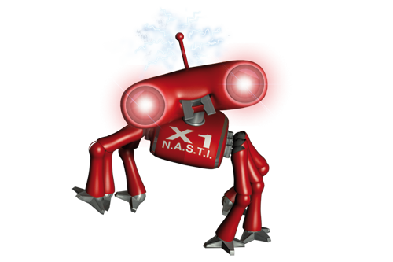
Chapters 3 and 4
Why isn’t the old tree a good hiding place?

Why is the island a better option?

What is a moat?

Why did Cat feel concerned on page 19?

How did the boys attach the castle to the boat?

How do the children turn small?

Why did everything get wet?

Building Vocabulary
Look these words up in a dictionary and write a sentence for each one:

camouflage:

hideout:

catapult:

Find words from the text which belong in each column:
Attacking Defending

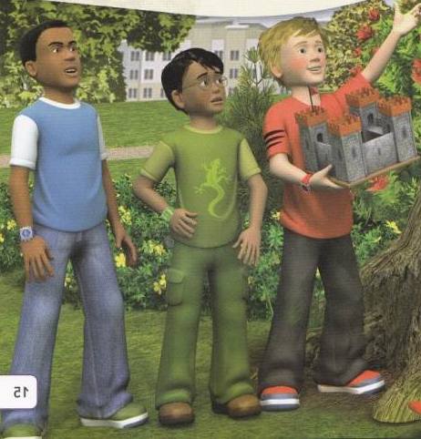
Grammar and Punctuation
The word X-bot has a punctuation mark.
What is this (-) called?
Find three more examples in the book.
List them here:

Apostrophes
Some apostrophes are for words that have been shortened. We call them contractions.
Read page 37 and find 4 examples of apostrophes.
eg: He’d he would

Using an or a
Fill in the space using an or a:
_____x-bot ____ watch ______castle
_____ army ______ island

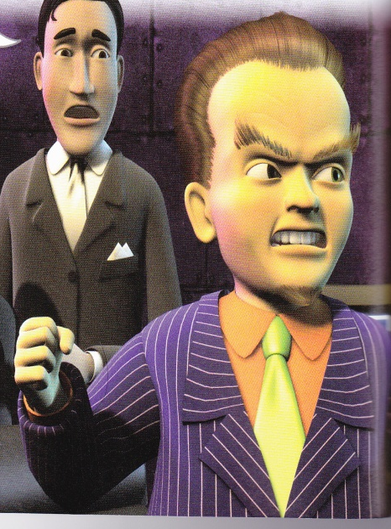
Re-read Dr X’s speech to the X-bots on page 43. Continue this speech, with Dr X explaining to the X-bots why he needs the watches and praising them for their design, intelligence and strength.
Don’t forget your wow words!

Vocabulary to use:designedfail
annoyingattackdesigned
weakcapturebeautiesfoolish

Imagine you are a real-estate agent and want to sell the castle on the island. Write a description of the castle. Try to use really persuasive language.

Chapters 8 and 9
What were the two instructions Dr X gave to the X-bots?

Why did the X-bots go through the drains?

How did Cat first spot the X-bots?

What did Tiger think it was?

What two choices did Max give the children?

What do you think will happen in the next book?
