after

after
fire

the

elephants
run
are

a

red
elephant

because

big
elephants
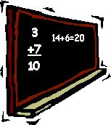
can
add
up
sums
easily
come

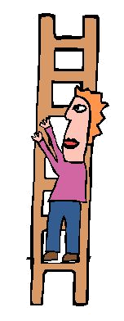
climb
on

my
elephant

here

here
elephants

run
everywhere

here
?

w

here
t
here
-ight

-

I
go

home
tonight

laugh

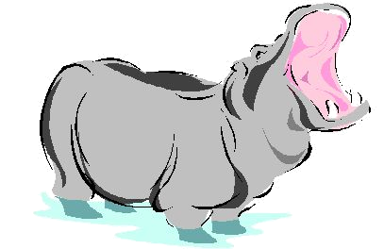
laugh
at

ugly

grey
hippos

little

little
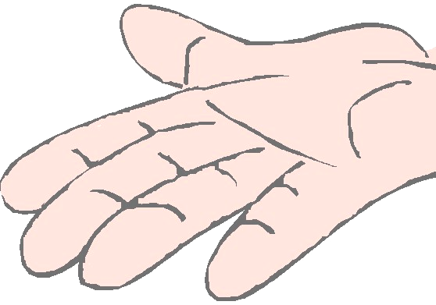
insects

try
to
look
evil
what

w hat

look
one

one
nice
elephant

only

only
nice
lions
yawn

ould

could should would
old
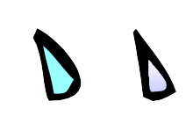
umbrellas
leak
drips
our

old

ugly
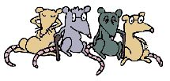
rats

people

people
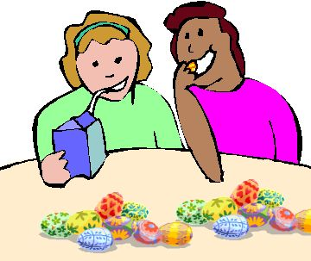
eat
only
pretty
little
eggs
said

Silly
animals

in
duckponds
saw

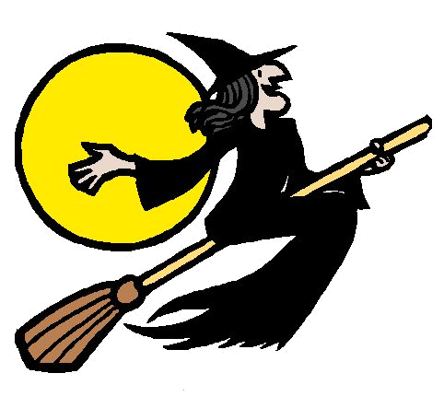

saw
a
witch

some

sit
on

my
elephant

there

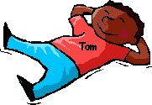
Tom
has

every
red
egg
want

want
a

nice
tiger?

was

what
a
sandwich!

water

water
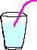
always

tastes
exactly
right

were

were
elephants
running
everywhere?

where

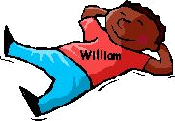
William
hates

every
red
egg
who

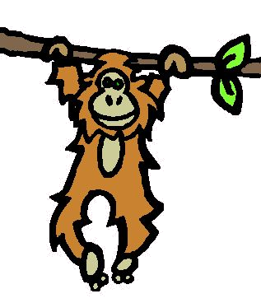

we
hang

on

you

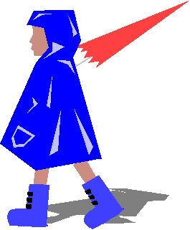

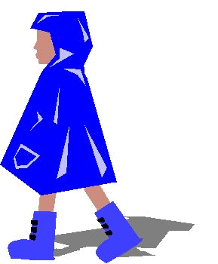
you
open
umbrellas

your

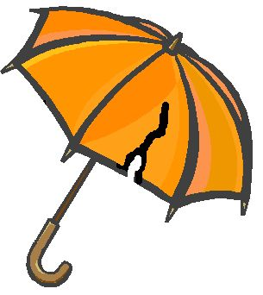

your
orange
umbrella
ripped

