ea | ay | a-e | ai | ee
y | ea | e | igh | i-e
ie | e_e | y | ow | o-e
oa | o | oo | u-e | ue
Tread on the bread. | Play in the day. | Make a cake. | A train in the rain. | A bee by a green tree.
A baby monkey. | Dream of tea! | Me, we, she, be, the, he. | The light was bright. | Ride a bike.
Pie on a tie. | Compete with the athlete. | Fly in the sky. | A crow in the snow. | A mole in a hole!
A boat on the road. | Go, no, so. | A goose on the roof. | A huge flute. | A true rescue.
ew | oo | ar | or | oor
ore | aw | au | air | are
ear | ir | ur | er | ou
ow | oy | oi | ire | ear
He threw a screw. | Look at a book. | Start the car. | A torch in a storm. | Shut the door.
More horses. | A prawn on the lawn. | Pause for sauce. | A fairy’s hair. | Care for a hare.
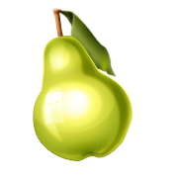  A bear with a pear. | A girl with a bird. | A nurse with a purse. | Under the drummer. |   A house for a mouse.
The clowns are in town. | Toy for a boy. | Point to the coins. | Fire, fire! | Hear with my ears.
ure | oe | ui | ou | u
A pure creature. | Lots of toes. | 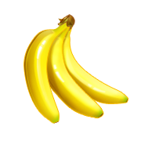  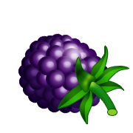  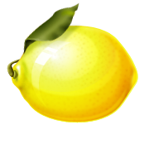  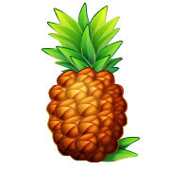  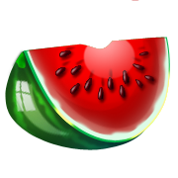  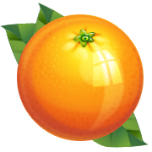  Fruit and juice. |   The group ate soup. | Super music.

Unfortunately these cards are not aligned to print out double sided. They are sized so that they can be mounted on to small flashcards.

