What is the last sound in these words?

r s t m n m c r a r p w u g s d

l y t s b w d n t r m d


t h d l y c d w m r p w b d s p

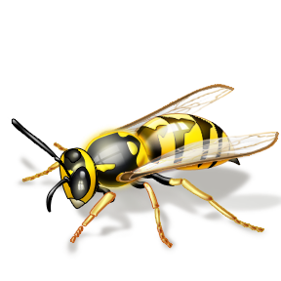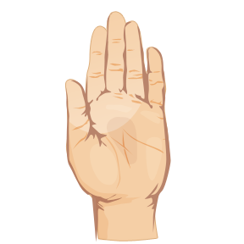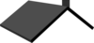
g b m t s y t w d n m b r f s w

