Write a short story about a bully that never gets into trouble.  (15+ sentences)   | Write a short story about a careless waitress.    (15+ sentences) | Write a short story about a deep sea diver’s encounter with a shark.  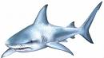  (15+ sentences) |   Write a description of a pirate. Your description should contain at least seven adjectives. |   Write a description of a burglar. Your description should contain at least seven adjectives.
Write a letter to the Prime Minister about how you would improve England if you were the Prime Minister.  (10+ sentences) | Write a letter to your headteacher explaining how you would improve your school if you were the headteacher.  (10+ sentences) | Write a letter to your parents or carers asking for £50 pocket money per week. Explain why you need this money.  (10+ sentences) | Write a letter to your best friend explaining the reasons why they are your best friend.  (10+ sentences) | Write a letter to your favourite football club explaining why they should employ you as a professional footballer.  (10+ sentences)

Write about your favourite ever dream.  (10+ sentences) | Write about your worst ever nightmare.  (10+ sentences) | Write a recount of your favourite holiday or school break.  (10+ sentences) | Write a humorous poem about a fat cat.   | 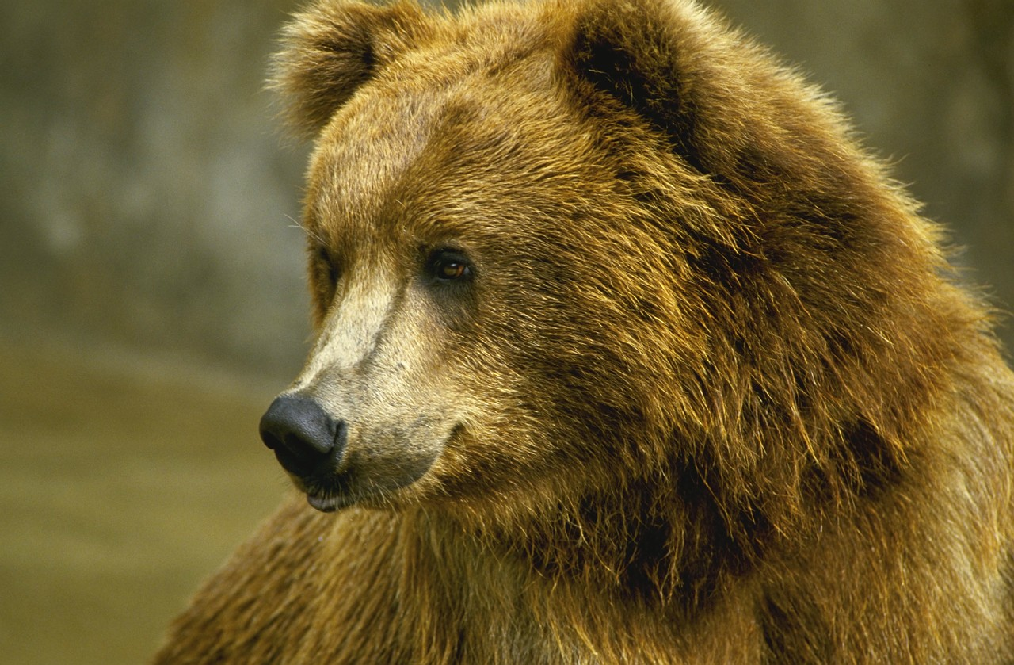  Write a humorous poem about a hairy bear.
List the reasons why the football team you support is the best team ever.    (15+ sentences | Write a recount of the best football match you’ve ever watched.  (15+ sentences)   | Write a short story about a football player that could never score goals.  (15+ sentences) | Write a short story about a ladies’ football team that wins the World Cup.    (15+ sentences) | Write a poem about your favourite football team.

Write a short story about a girl that always played tricks on her brother.    (10+ sentences) | Write a short story about an unloved cat.  (10+ sentences)   | Write a short story about a teacher that always got things wrong.  (10+ sentences) | Write a description of an eagle. Your description should contain at least ten adjectives.  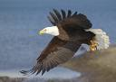 | Write a description of a giraffe. Your description should contain at least eight adjectives.  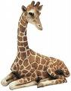
Write a short story about an alien invasion.  (10+ sentences) | Write a short story about a friendly monster that lives under a child’s bed.  (15+ sentences) | Write a short story about some troublesome twins.  (15+ sentences) | Write a short story about an ugly fish that grew beautiful.  (10+ sentences) | Write a letter to your teacher about what you would most like to learn about and why.  (10+ sentences)

