Date: _______________________
Remember, a verb is an action
WALT: Use imperative verbs.
Imperative verbs are bossy verbs.
E.G. walk, turn, climb, swim, look, dig.
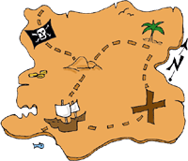
Create a treasure map with 5 landmarks (eg ;Dead Man’s Swamp, Blood River)

Write a set of instructions to follow to get to the treasure. Begin each sentence with an imperative verb.
How To Find The Treasure
______________________________________________________________________________________________________________________________________________________________________________________________________________________________________________________________________________________________________________________________________________________________________________________________________________________________________________________________________________________________________________________________________________________________________

