Year 4 – Autumn Term Jamaica Quiz

- Find Jamaica on the world map and cross out the wrong words in the sentences.
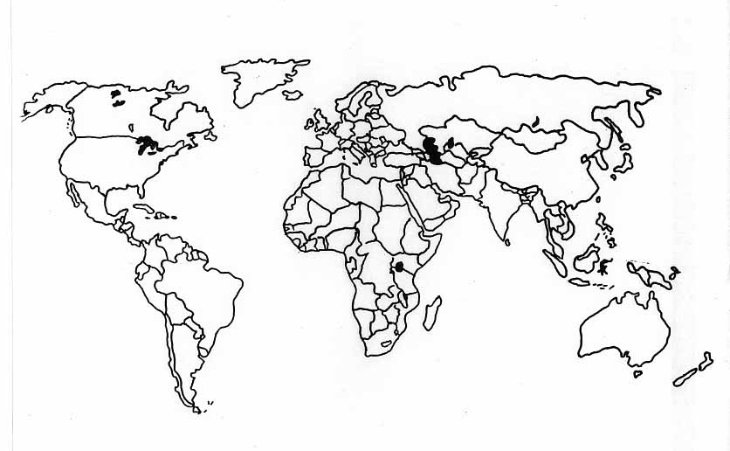
  - A country to the north of Jamaica is USA / Brazil.

  - A country to the west of Jamaica is Mexico / UK.

  - Far away to the east of Jamaica is Europe / Africa.

- Are the sentences about Jamaica below true?

  - Jamaica is in the Caribbean. ______

  - Jamaica has a coastline. _______

  - Jamaica has a big city called London. _______

  - Kingston is a town in Jamaica. _______

- Use the words from the cloud to complete the pilot’s description of how to get the Jamaica.

Kingston
airport
Atlantic
eight
Caribbean

First I have to leave Heathrow _______________________.

I go towards the English Channel and then turn west. Soon I am flying

over the _____________________Ocean. I keep going for about

____________________hours. Then I pass over the

___________________sea. Finally I land in Jamaica’s main town,

________________________.

4)
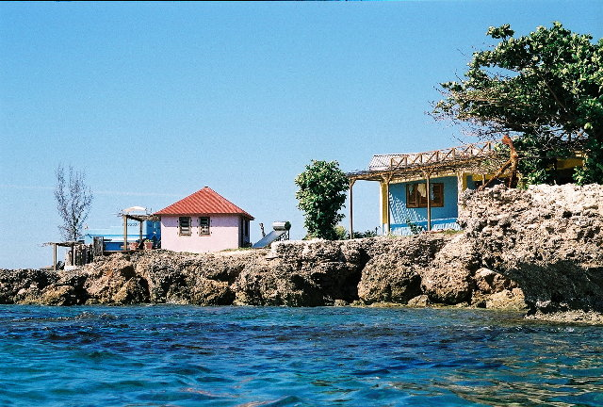
Look at this picture of 2 houses in Jamaica. Draw a circle around the words below that best finish the sentence.
- The houses are generally in GROUPS / VERY FAR APART.
- The roofs are made of STRAW / TILES.
- The villagers build their homes CLOSE TO THE WATER / IN THE JUNGLE.

5)
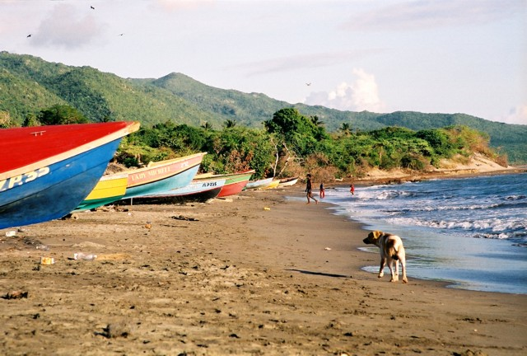
Look at this picture. Tick the sentences that go with the picture.

The sea can be seen. There are only a few trees and plants.
It looks hot and sunny. There are mountains with snow on them.
The beach is used for tourism. The beach is used to store boats.

6) Look at the pictures again. Can you list some human and physical features in the picture?

Human Physical
______________ ________________

______________ ________________

7) Look at these pictures of homes in Jamaican and England. Then decide if the sentences are true (T) or false (F).
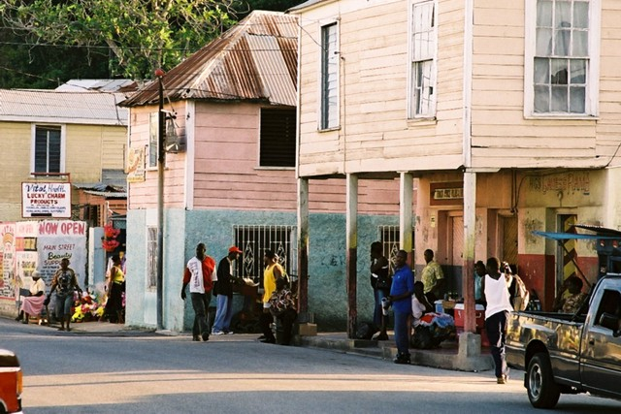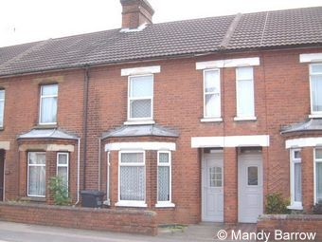
Jamaica England

- In both countries, houses are near each other.
- In both countries, the houses are made of brick.
- In both countries the houses have glass windows.

8) Look at the pictures below or trade in Jamaica.
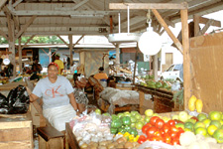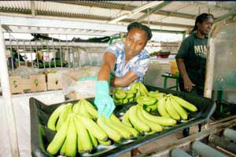

Tick the sentence to show what you can see in the pictures.

Market Fruit
Roads Crops
Field of plants Workers

Circle the correct ending for each sentence.
- The market stalls are INSIDE / OUTSIDE.
- People can buy a TV / THINGS PRODUCED BY FARMERS.
- People need MONEY/CRISPS to buy the goods.

Unscramble these words to describe how Jamaicans get to market.

People don’t go by LDSEEG. SLEDGE
Most people LAWK. __________
Some people might have a TRAC, or KIBE. __________ _____________
A few people may travel by RAC. _____________________

