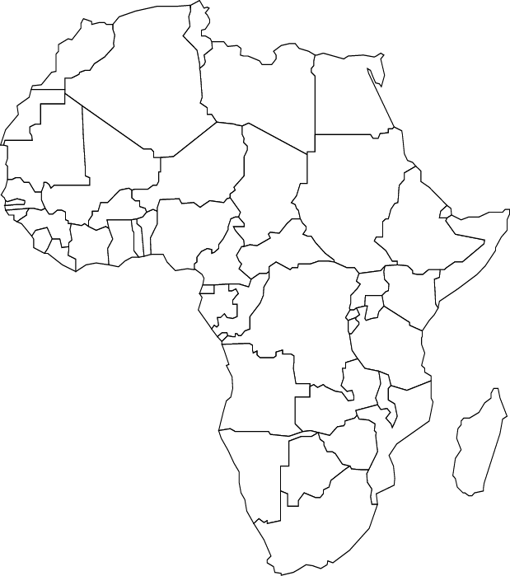
AFRICA

- __________ is a continent.
- Name three countries in Africa:
__________, __________,
__________ .
- There are __________
countries in Africa altogether.
- The smallest country is __________. The largest country is __________.
- The __________ Ocean is West of Africa.
- The __________ Ocean is East of Africa.
- The __________ sea is North of Africa.
- Name a lake in Africa: __________.
- Name a river in Africa: __________ .
- Write in the names of the countries in the outline of the map.
NOTES FOR TEACHERS!

Your students will need to use different maps and atlases to find the answers to the questions.

- AFRICA is a continent.
- Name three countries in Africa:
- There are 53 countries in Africa altogether.
- The smallest country is SEYCHELLES. The largest country is SUDAN.
- The SOUTH ATLANTIC Ocean is West of Africa.
- The INDIAN Ocean is East of Africa.
- The MEDITERRANEAN sea is North of Africa.

Name a lake in Africa: (THERE ARE 69 LAKES – MAIN ONES ARE VICTORIA, TANGANYIKA, ALBERT, MALAWI, KIVU, EDWARD

- Name a river in Africa: SENEGAL, ORANGE, LIMPOPO, ZAMBEZI, VOLTA, BENUE, NILE, BLUE NILE, WHITE NILE, NIGER, CONGO.

