CUTTING DOWN RAINFORESTS
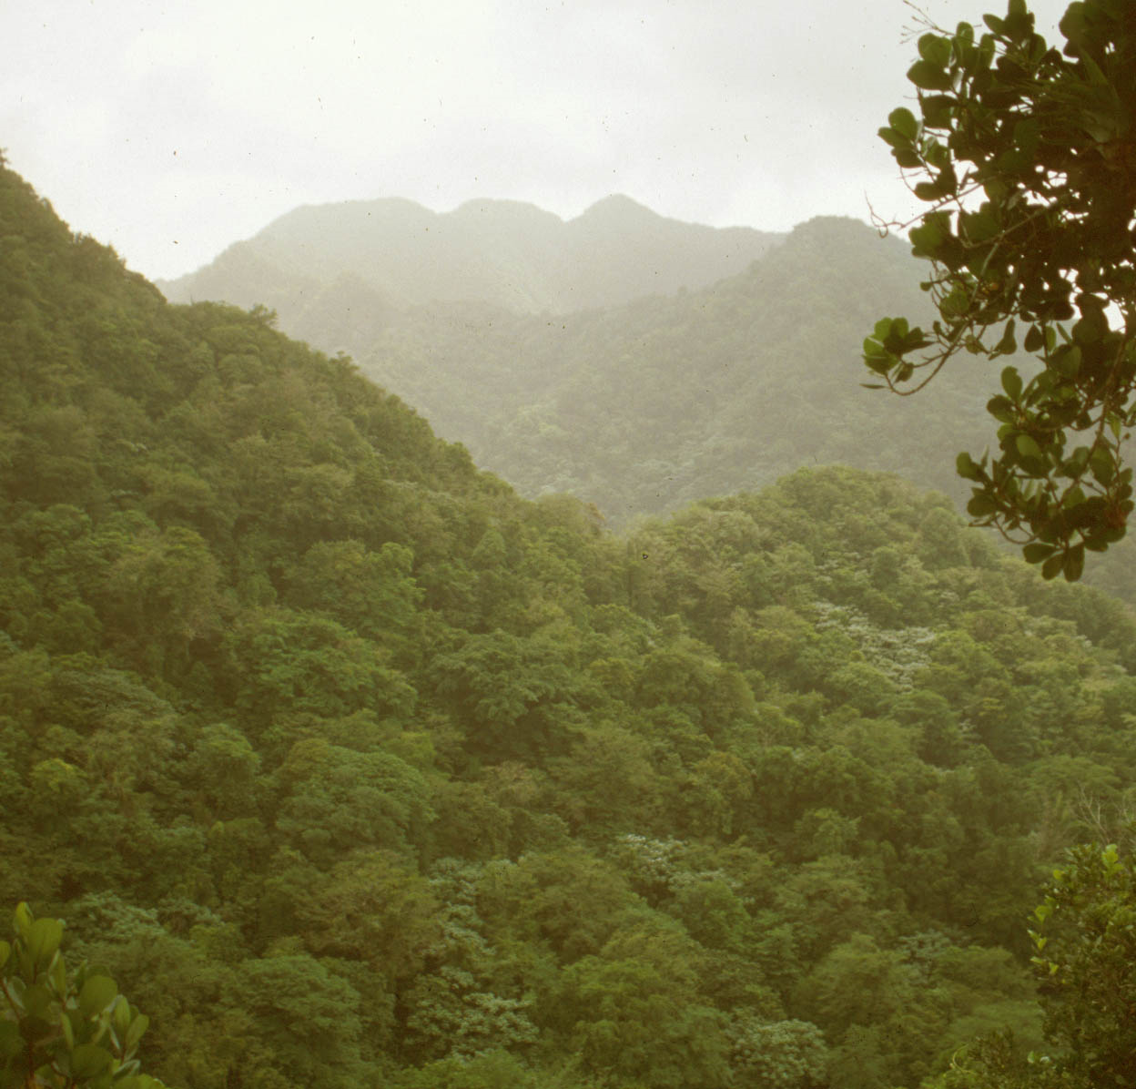
This is a Rainforest in Brazil, and there are plans to chop down a large section of these trees. Below are some reasons why people might be in favour of this happening.

- The rainforests cover a large area, and as population grows, people need somewhere to live. Cutting down trees can make room for new homes, roads and schools.
- The cleared areas could also be used for Hotels and other tourist attractions which would bring jobs and money to the local area.
- People who live in rainforests may clear small areas to grow food in.
- Wood from the trees which have been cut down can be used to build many different things such as homes and furniture
- It can be made into card and paper which has a variety of uses for everyone from toilet paper to birthday cards.
- Wood can be burned in fires to cook food, use as lights or to keep people warm.
- The wood timber and construction industries give jobs to many local people who would struggle to survive if they no longer had a job.

Can you think of a compromise?

CUTTING DOWN RAINFORESTS
This is a Rainforest in Brazil, and there are plans to chop down a large section of these trees. Below are some reasons why people might be against this happening.

- People live in the rainforests and they may lose their homes and their way of life if trees around them are cut down. Being re-homed in a city wouldn’t be the same.
- Many different plants and animals exist only in rainforests, and if they no longer have a place to live their species is at risk of becoming extinct.
- 20% of the Oxygen we breathe in produced in the Amazon rainforest, and we need this Oxygen to survive.
- Many plants used in medicines have been found in rainforests. If we destroy the rainforests we could destroy life-saving medicines.
- There are other things which people can use for light and heat without having to burn wood on a fire. Electricity doesn’t fun out but trees might!

Can you think of a compromise?

