India
India has over 700 million people living in it. This is called its population. There is a range of mountains in India known as the Himalayas. The people in India mostly live in villages and work on farms. Most farms are very small and the farmers work hard with simple tools for not much money. The farmers cannot grow crops quick enough because there are so many people living in India who eat it quickly. Most of the rain comes in a few weeks of the year this is called the monsoon season and usually is in the months of June to September or October. The government have thought of an idea which will help to save the rain from the monsoon season for the dry months. They want to build dams to hold the water. Dams are big holes in which water can be stored. The capital city of India is New Delhi and people who live here often work in factories and offices because there is not much land free to farm.
Questions to be answered in full sentences in your books:
- What is the population of India?
- What is the name of the mountain range in India?
- Write a sentence about farmers in India.
- What is the monsoon season?
- What was the governments idea to help the crops?
- What is a dam?
- What is the capital of India, and what do people who live here usually do for jobs?
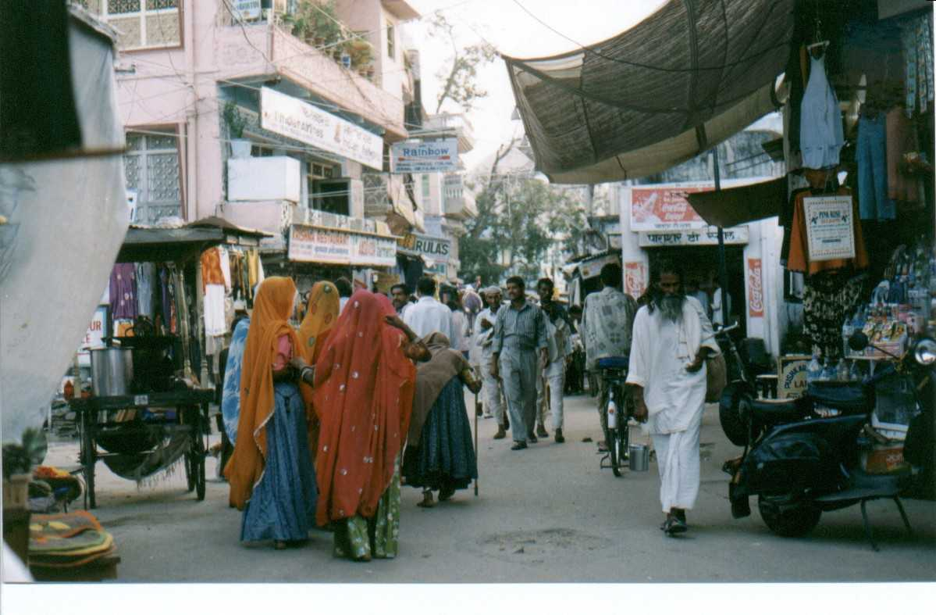
People in the street in Bangalore.

