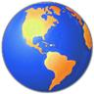
Investigating Countries Around the World

Country:_______________________________

What is the capital city?________________________________

What is the name of the highest mountain ?__________________

How high is this mountain?_______________________________

What is the longest river called?__________________________

How long is this river?__________________________________

What is the population of the capital city?___________________

What foods are grown in this country?

What is the climate like in this country?_____________________

Now draw the flag of this country!

