Africa Webquest
Which countries border Kenya?

What is the capital of Kenya? _____________________________________
What money do they use in Kenya? _________________________________
What are the official languages of Kenya? ____________________________
What does the flag of Kenya look like?

What is Wayua’s favourite food? _________________________
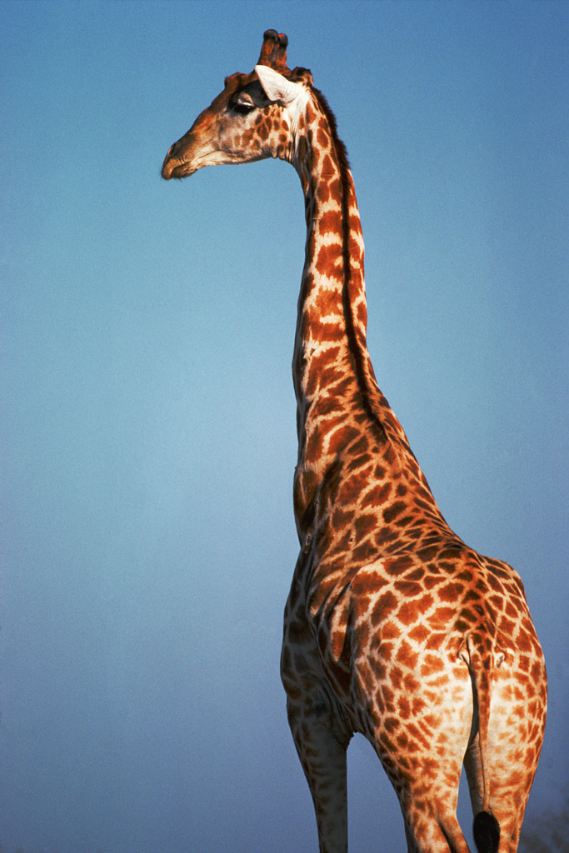
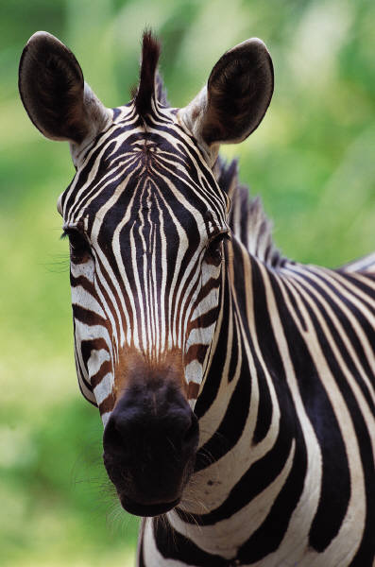
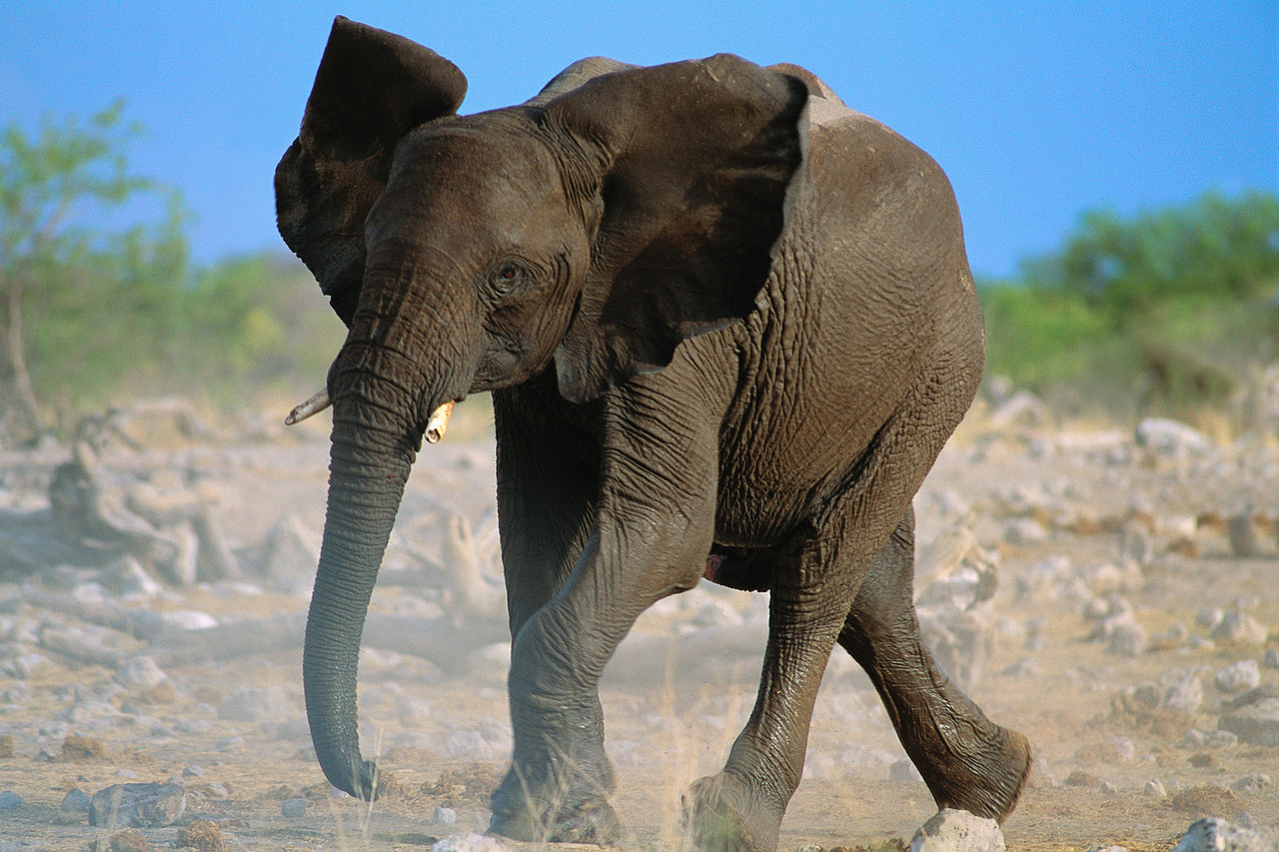
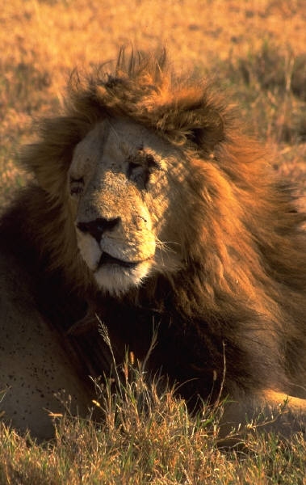
Which tune do you like most played on the
thumb piano?
What can you find out about African animals?
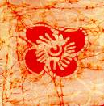
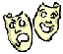
What is Bokolanfini?

What were the three tests Prince Sadaka had to pass?
1.__________________________________________________________________
2. _________________________________________________________________
3. _________________________________________________________________

What can you find out form children’s postcards about chores, books and television in Kenya?

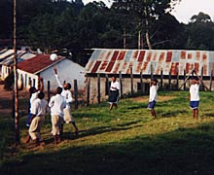

What sports do the children play at school? ________________________________________
Find the name of a teacher. ____________________________________________________
Where do the students shop? ___________________________________________________
What entertainment do they have?_______________________________________________
What is the cafeteria like? ____________________________________________________

