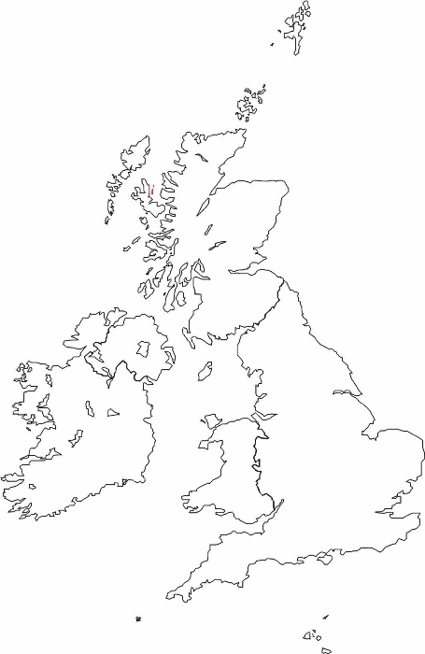
Name of location: ___________________________________________

What type of location is it? (village, town or city)

Where is the locality? (England, Scotland, Wales, Northern Ireland or Ireland)

What do we know about the locality by looking at a map?
(Is it near any rivers, mountains or capital cities?)

Through research I have found out about ….
* Transport – bus/train station/busy roads * Population
* Leisure activities * Weather
* Industry
(Any main jobs that the people live there have?)

Other questions that I would like to ask about this place are ….

