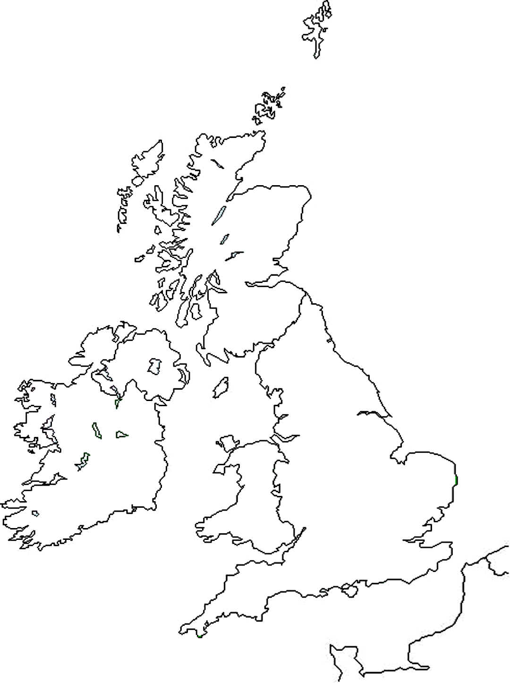
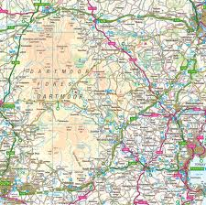
Can you could in the map of Great Britain?

Colour Northern Ireland Yellow
Colour Southern Ireland Blue
Colour England Green
Colour Scotland Orange
Colour Wales in Red

