Germany

Flag
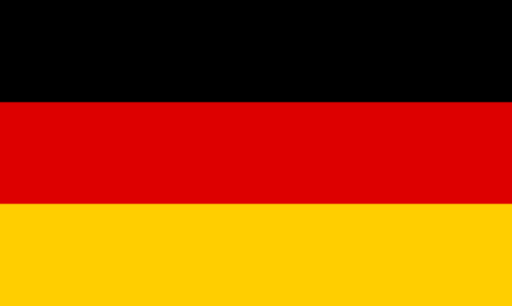
Public domain

Map
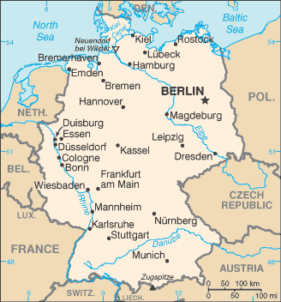
CIA World Factbook, Public Domain via Commons
Cities in Germany
Berlin
Bonn
Cologne
Dresden
Düsseldorf
Frankfurt
Hamburg
Leipzig
Munich
Stuttgart

Bodies of water
North Sea
Baltic Sea
Danube River
Elbe River
Rhine River
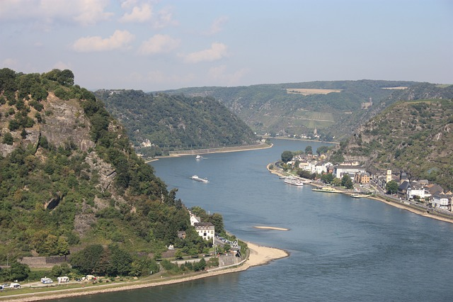
Public domain
Language spoken in Germany
German is the main language

Currency of Germany
Euro
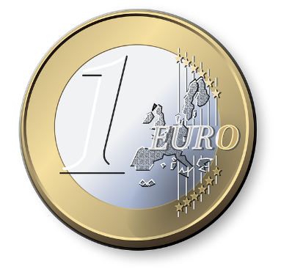
Public domain

Countries close to Germany
Austria – Mozart and Strauss came from Austria
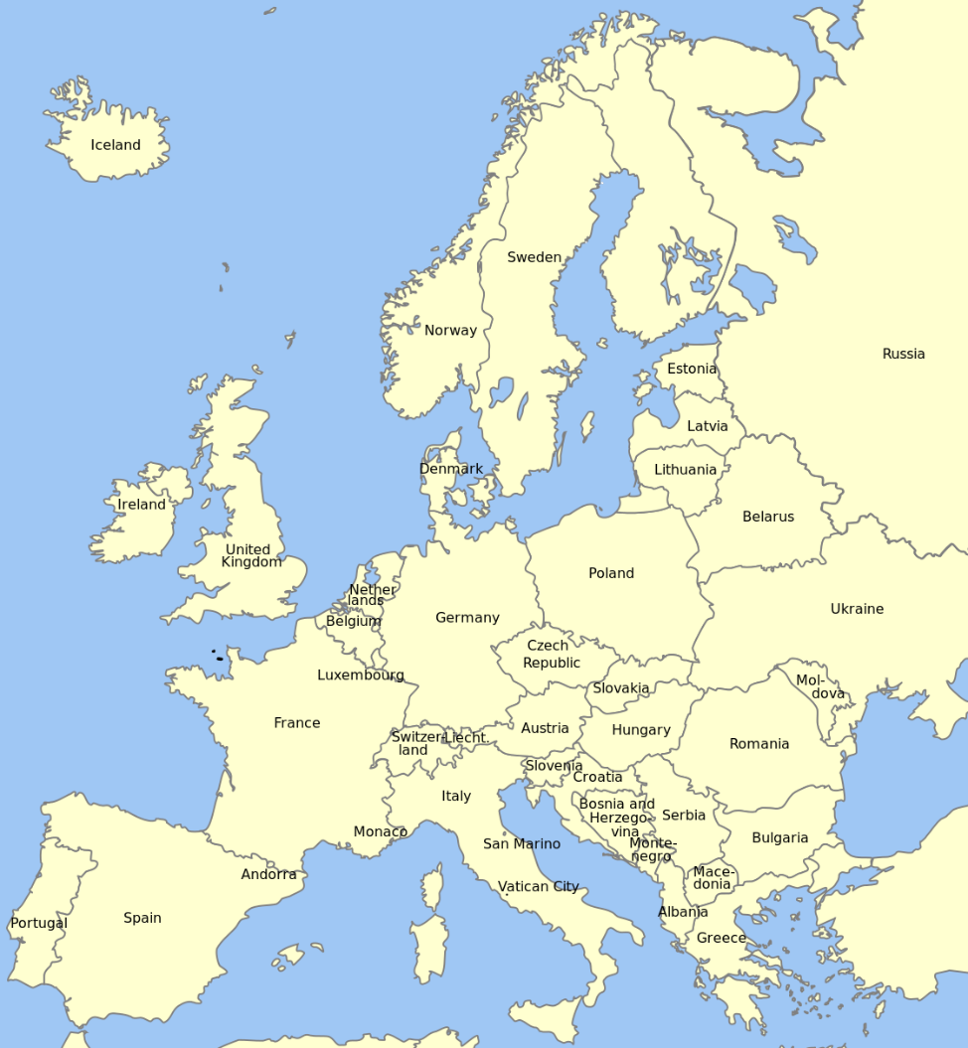
Belgium
Denmark
France
Netherlands
Poland
Switzerland

George Esayas, Creative Commons: Attribution- Share Alike
Famous people from Germany

Einstein – scientist, teacher, author
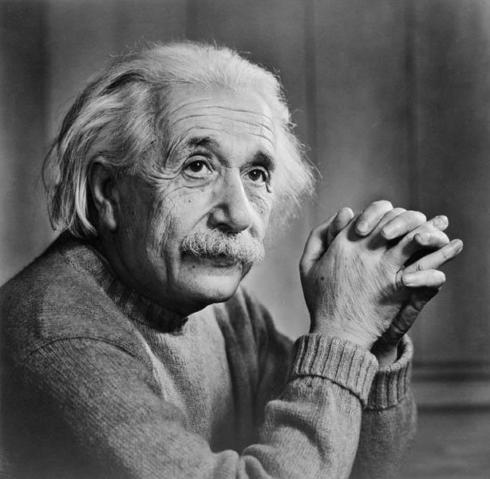
Public domain

Johann Sebastian Bach –musician and composer
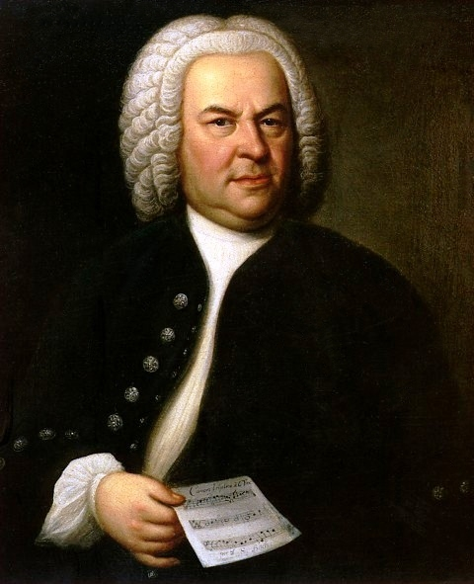
"Johann Sebastian Bach" by Elias Gottlob Haussmann, licensed under Public Domain via Commons
Ludwig van Beethoven – musician and composer
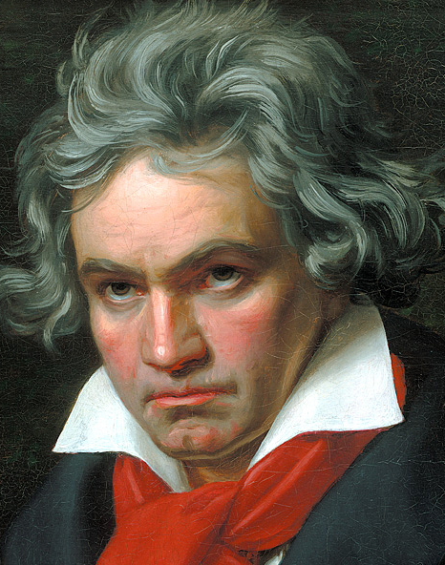
Public domain

Germany is known for exporting cars
BMW
Volkswagen
Mercedes
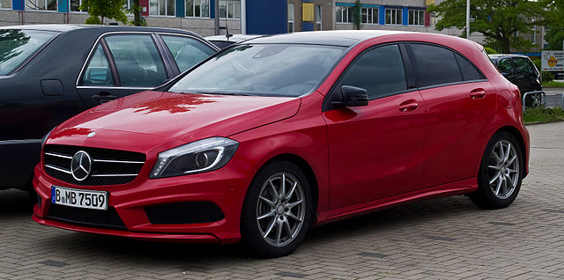
Mercedes Benz
© M 93 / Wikimedia Commons / CC-BY-SA-3.0 (DE)

Architecture of Germany
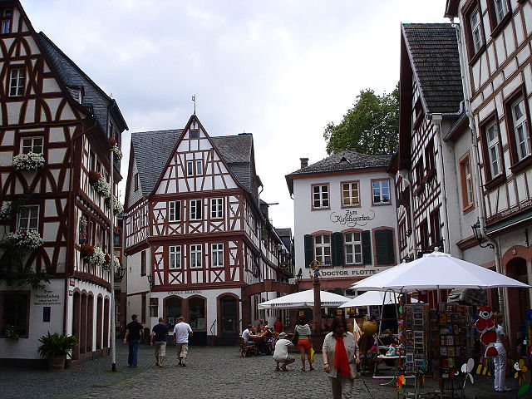
The Kirschgarten of Mainz, Germany
Theodoranian/Titan Deng, Creative Commons Attribution-Share Alike

Transport in Germany
Public transport in Germany is excellent
Rail
Subway
Tram
Buses
Cars
Taxis

Famous foods of Germany
Sauerkraut
Bratwurst
Beer

Animals of Germany
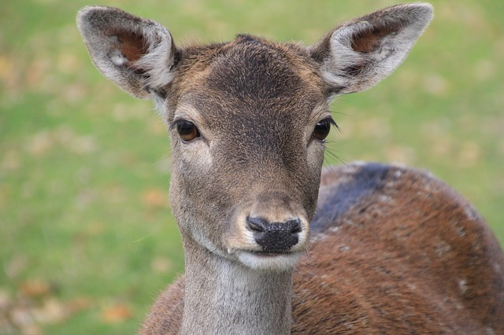
Roe deer, Dülmen, Germany
CC0 Public Domain

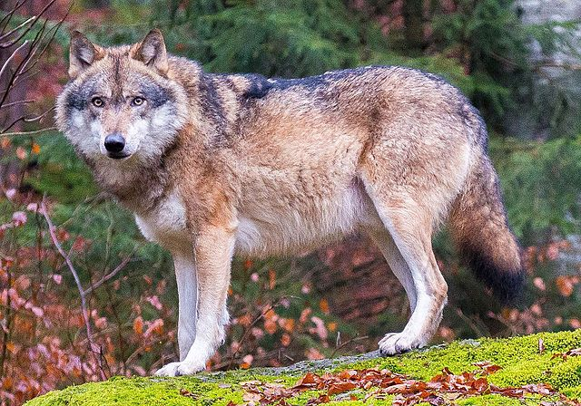
Grey wolf in Bavarian Forest National Park
Creative Commons Attribution 2.0 Generic

Forest and lake in Germany
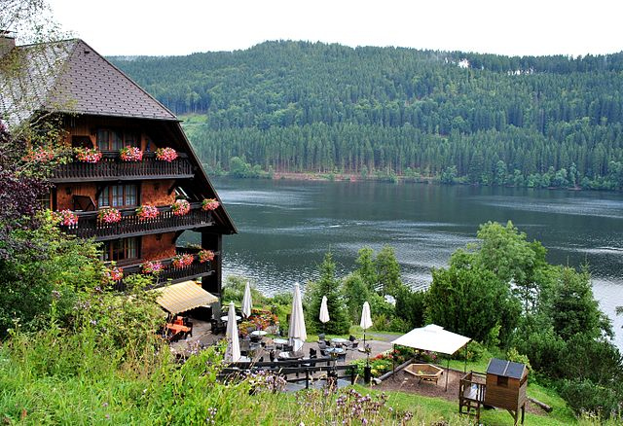
Lake Titisee, Black Forest, Germany
Ignaz Wiradi, Creative Commons Attribution-Share Alike

Mountain range in Germany
Alps
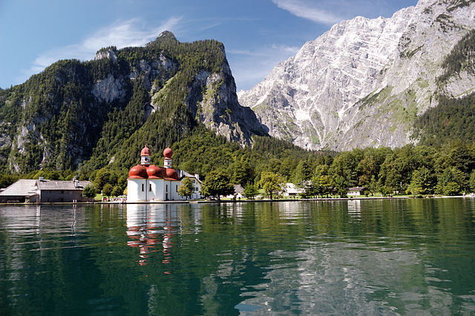
Marco Tesch, Creative Commons Attribution-Share Alike

