Boudicca

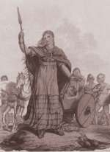
- Who was the king of the Iceni?

__________________________

2. Who was his wife?

__________________________

3. Why did she not like the Romans?

______________________________________________

4. Where did she march to?

___________________________

5. What did she do?

