The Victorians



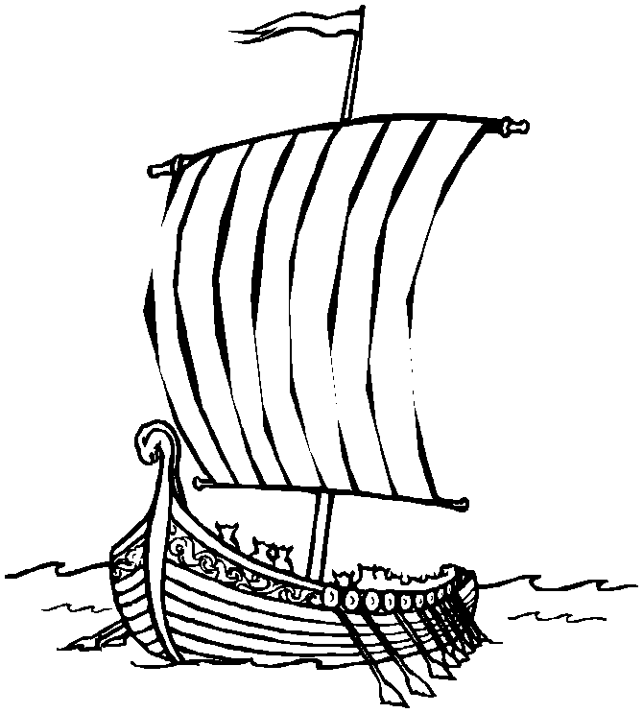

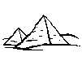
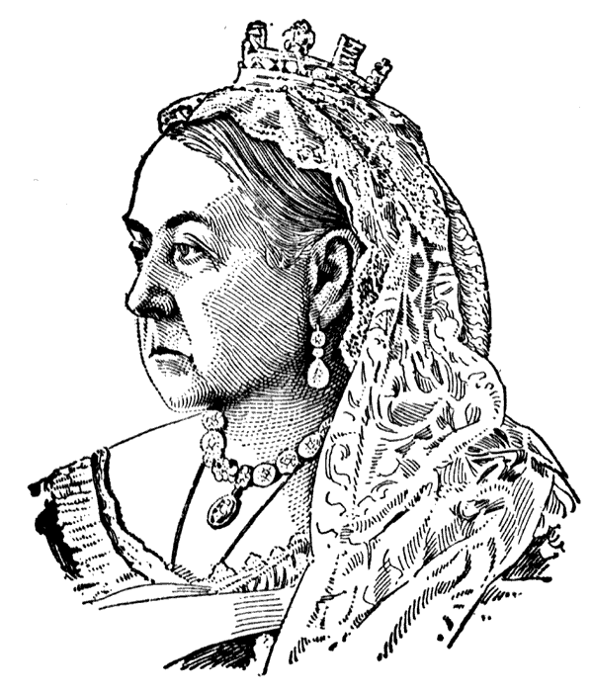
Can you cut out the pictures below and place them in the correct position on your time line.
First man 200,000 years ago.
Birth of the Earth
450 million years ago
Dinosaurs on the Earth
80 million years ago
Me at school today.
First man on moon
1969
World War 2
begins
1939
I was born
1996/1997
First PC
1966
First Vikings
AD 789
First Roman
753 BC
Jesus was born
0 BC
Tudor s
1435 AD
Ancient Egypt
3000 BC
THE VICTORIANS
1819 - 1901
The Victorians

