Roman Gladiators

Life as a Roman Gladiator was not a very nice one. They were either slaves from defeated tribes or criminals and for the entertainment of the Roman citizens they were made to either fight each other to the death or had to fight wild animals like bears and lions. The more gory and bloody the battle the more the crowd cheered.

Gladiators life was not a free one at all, they were locked up in a training school where they were trained to fight by an old gladiator who didn’t have to fight anymore; not that there were many of those. They had to lift weights and exercise everyday to get fit and they also had to practice sword fighting with wooden swords. Once trained, they had to fight each other in the front of the Roman audience in the amphitheatre.

Gladiators were trained to be a certain sort of fighter and they would try to become as good a fighter as possible. They had to fight to win, to loose as a gladiator would mean death in the fighting contest.

Some Types of Gladiators:

Andabatus – was a gladiator who wore a helmet with no eye holes and used to charge blindly around the arena on a horse.

Samnite – has a visor on his helmet that had a crest, he carried a large shield and sword. 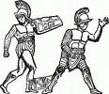 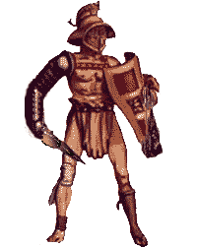

Retarius – tried to catch his opponents in his net. His left arm and shoulder were protected with armour. He had a large fork like weapon for stabbing, this was called a trident.

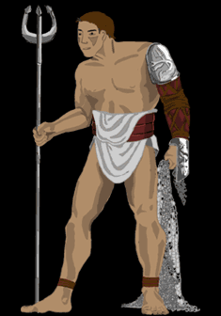 A Retarius Gladiator.

Velitus – he was only armed with a spear.

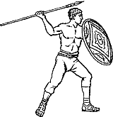 A Velitus Gladiator

Secutor – was also lightly armed and had to chase his opponents to fight them.
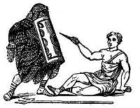The secutor is the one on the ground.

Laquerius – was similar to a retarius but with a lasso instead of a net.

Once the training of the gladiator was complete he was then to fight in the amphitheatre. Romans loved the gladiator fights they attended in huge numbers and the Emperor himself would go to big fights. People would gamble on the outcome of the fights and the games would be the focus of the entertainment for the whole day.

The different types of gladiators would be set against each other and would fight bloody battles with each other. The loser would at the end of the fight call the support of the Emperor or the crowd to decide his fate. If the Emperor declared the gladiator to die then the winner killed him. If the gladiator had put up a fierce fight that pleased the Emperor and the crowd they would spare his life.

Questions:

1. What do you think the life of a gladiator was like?

…………………………………………………………………………………………………………………

………………………………………………………………………………………………………………..

…………………………………………………………………………………………………………………..

………………………………………………………………………………………………………………….

………………………………………………………………………………………………………………

2. Where did the gladiators fight?

………………………………………………………………………………………………………………

3. Where gladiators free?

…………………………………………………………………………………………………………………

…………………………………………………………………………………………………………………

4. Describe how gladiators trained?

…………………………………………………………………………………………………………………

…………………………………………………………………………………………………………………

…………………………………………………………………………………………………………………

5. Draw a picture of a retarius gladiator and velitus gladiator fighting in the space below.

6. Do you think that the Roman crowd was blood thirsty and why?

………………………………………………………………………………………………………………

………………………………………………………………………………………………………………

………………………………………………………………………………………………………………

………………………………………………………………………………………………………………

………………………………………………………………………………………………………………

………………………………………………………………………………………………………………

7. How could the loosing gladiator live?

………………………………………………………………………………………………………………

…………………………………………………………………………………………………………………

…………………………………………………………………………………………………………………

…………………………………………………………………………………………………………………

…………………………………………………………………………………………………………………

8. You are an ancient Briton and you have been captured by roman soldiers in a fight. You have been sent Rome and sold at a slave market to the gladiator training school. You are training to be a samnite gladiator. Your life is hard you are up at dawn and you train all day. You have to lift huge weights to make your muscles strong and have practice fights with other gladiators. Finally the day you have dreaded has arrived you have to fight before the Emperor. Your fight has been drawn and you have to fight a retarius gladiator. Write a story describing your battle in the amphitheatre.

………………………………………………………………………………………………………………

………………………………………………………………………………………………………………

………………………………………………………………………………………………………………

………………………………………………………………………………………………………………

……………………………………………………………………………………………………………….

………………………………………………………………………………………………………………..

………………………………………………………………………………………………………………..

…………………………………………………………………………………………………………………

…………………………………………………………………………………………………………………

…………………………………………………………………………………………………………………

…………………………………………………………………………………………………………………

…………………………………………………………………………………………………………………

…………………………………………………………………………………………………………………

…………………………………………………………………………………………………………………

…………………………………………………………………………………………………………………

…………………………………………………………………………………………………………………
8. your gladiator story. .................................................................................

…………………………………………………………………………………………………………………

…………………………………………………………………………………………………………………..

…………………………………………………………………………………………………………………..

…………………………………………………………………………………………………………………..

…………………………………………………………………………………………………………………..

…………………………………………………………………………………………………………………..

…………………………………………………………………………………………………………………..

…………………………………………………………………………………………………………………..

…………………………………………………………………………………………………………………

………………………………………………………………………………………………………………….

………………………………………………………………………………………………………………….

…………………………………………………………………………………………………………………..

…………………………………………………………………………………………………………………..

…………………………………………………………………………………………………………………..

…………………………………………………………………………………………………………………..

…………………………………………………………………………………………………………………..

…………………………………………………………………………………………………………………..

