Roman Gods

To the Romans their gods were an important part of their lives and were treated as part of their families. The Romans had many gods that they thought were just like them but only bigger.

The most important gods to the Romans were the Greek gods who lived on a mountain called Olympus, they just called the Greek gods by Roman names. Just like the Greeks, the Romans had wondrous and fantastic stories about their gods.

Usually they built their temples to just one or sometimes two of the gods. But sometimes they build wonderful temples to all of their gods and this building was called a pantheon.

In the days of the Roman Empire the Roman people also believed that their Emperors were gods and made sacrifices to them. Of course, the Emperors were not gods and sometimes they were not good rulers.

Roman Gods:

Jupiter Was the king of the gods and was the god that ruled the sky. Jupiter’s weapon was the Thunderbolt, thunder and lightening. He ruled all the gods and they were afraid of him. The Romans believed that Jupiter protected the City of Rome and they built a huge temple to him.

Juno Was the wife of Jupiter, queen of the gods and she was the goddess of women and marriage. She was the mother of Mars. Roman women gave thanks to Juno in a festival called Matronalia. The month of June comes from her name. Juno could be very fierce and she too could hurl thunderbolts. Juno is always shown with her favourite bird the peacock.

Neptune Was Jupiter’s brother and was god of the sea. He is always shown with a trident which is like a big fork with three prongs. Neptune rode through the sea on dolphins or horses, he was also god of earthquakes and was called the earth shaker. Neptune also had a fierce temper and storms and earthquakes were a show of his furious rage.

Questions:

1. What did the Romans think their gods looked like?

…………………………………………………………………………………………………………………..

…………………………………………………………………………………………………………………..

2. What was the name of the king of the Roman gods?

…………………………………………………………………………………………………………………

3. Draw a Shield with the weapons of Jupiter on it.

4. What was the name of the queen of the gods and what was her favourite bird?

…………………………………………………………………………………………………………………

…………………………………………………………………………………………………………………

…………………………………………………………………………………………………………………

5. What is the name of the month of the year that is named after Juno?

………………………………………………………………………………………………………………

6. What was Neptune the god of?

………………………………………………………………………………………………………………

………………………………………………………………………………………………………………

7. What did the Romans believed happened when Neptune was in a rage?

…………………………………………………………………………………………………………………

…………………………………………………………………………………………………………………

8. What things are always shown with Neptune?

…………………………………………………………………………………………………………………

…………………………………………………………………………………………………………………

9. Draw a picture of Neptune with his trident and riding on dolphins

More Roman gods:

Mars Was the son of Juno and Jupiter and was the Roman god of war. He was a very important god to the Romans and they said that he was the father of Romulus and Remus who were the founders of Rome. All Romans thought they were descended from mars and he was one of the most popular of the Roman gods. When the Romans held festivals in honour of Mars they would sacrifice goats, sheep and bulls. Mars was one of the only gods who had bulls sacrificed to him.

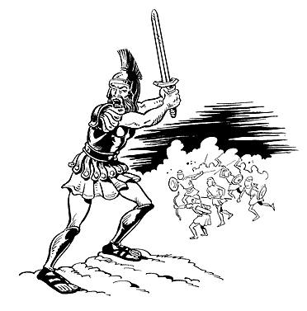The god Mars in battle

The month of March comes from the god’s name and his symbol was the spear and the shield.

Venus She was the goddess of love and beauty and was the daughter of Jupiter. Venus was born in the sea and came ashore on the Island of Cyprus floating in a sea shell. She was the mother of Cupid who was the god of love. Her symbol is the bird called the dove which is also the bird of peace.
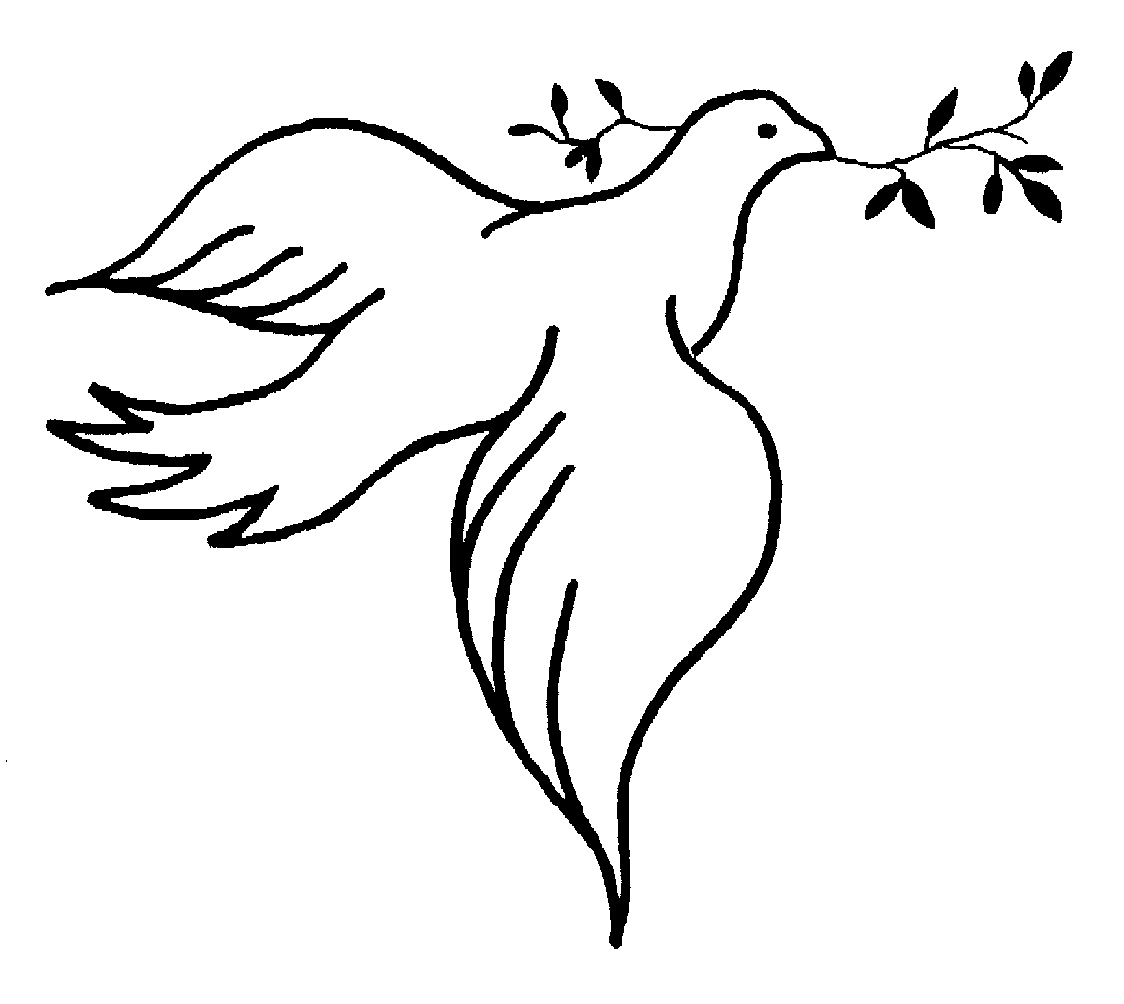 A dove, symbol of the goddess Venus.

Cupid Was the god of love and the son of Venus. His weapons were the bow and arrows anyone hit by Cupid’s arrows fell madly in love. Once he scratched himself with his own arrow and fell in love with a beautiful woman call Psyche. He knew Venus would be very angry so he hid Psyche away and said that she should never look at him. Psyche thought she had been captured by a monster so she peeked out and saw Cupid and fell in love with him. Venus sent Psyche away but eventually let Cupid and Psyche remain together. When Psyche died Cupid loved her so much he made her into a goddess.

Questions:

1. What was the name of the god of war?

………………………………………………………………………………………………………………

2. Which gods were his parents?

…………………………………………………………………………………………………………………
3. Why did the Romans think they were descended from Mars?

…………………………………………………………………………………………………………………

…………………………………………………………………………………………………………………

…………………………………………………………………………………………………………………

…………………………………………………………………………………………………………………

…………………………………………………………………………………………………………………

4. What did the Romans used to sacrifice to Mars?

…………………………………………………………………………………………………………………

5. What do you think sacrifice means?

…………………………………………………………………………………………………………………

…………………………………………………………………………………………………………………

6. Draw the symbols of Mars

7. Where was Venus born and what was she the goddess of?

…………………………………………………………………………………………………………………

………………………………………………………………………………………………………………….

…………………………………………………………………………………………………………………

8. What was the symbol of Venus?

…………………………………………………………………………………………………………………

9. What was the name of the son of Venus and what was he god of?

…………………………………………………………………………………………………………………

………………………………………………………………………………………………………………….

…………………………………………………………………………………………………………………

10. What were his weapons?

………………………………………………………………………………………………………………

11. What happened to people who got hit by Cupid’s arrows?

………………………………………………………………………………………………………………

12. Who did Cupid himself fall in love with and what did he do when she died?

………………………………………………………………………………………………………………

………………………………………………………………………………………………………………
Even More Roman Gods:

Apollo Was the god of the son of Jupiter and god of the sky. The Romans believed that he lit the world by driving his fiery horses across the sky everyday. Apollo was also a wise god who was believed to tell the future he was also the god of poetry and music.

Pluto Was the god of death he was the brother of Jupiter and ruled the underworld. The Romans believed that when people died they had to travel to the underworld, here they had to cross the river Styx and to cross they had to pay the ferryman Charon. So everyone who died was buried with a coin to pay Charon to take them across the river. The dead then had to pass a fierce dog with three heads who would only allow the dead to pass before they went before the judges of the dead.

Saturn Was the god of time he ruled the gods before Jupiter, Saturn was also the god of farming and the harvest. Jupiter Neptune and Pluto were his sons. The Romans believed they represented air, water and death, which could not be killed by time. The Romans held a celebration of Saturn every year in the middle of winter, it was called Saturnalia and lasted for seven days. During this festival all businesses and schools were closed. Parents would by toys as presents for their children, drink and eat lots and have parties. Just like our Christmas.
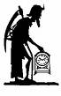 Saturn as Old Father Time.

The Romans had many more gods. Sometimes families would have shrines in their homes to their favourite god and would put offerings of flowers and statutes of the god in the shrine.

Questions:

1. Who was Apollo?

………………………………………………………………………………………………………………

…………………………………………………………………………………………………………………

…………………………………………………………………………………………………………………..

2. How did the Romans believe Apollo lit the sky?

…………………………………………………………………………………………………………………..

…………………………………………………………………………………………………………………..

…………………………………………………………………………………………………………………

3. What was Pluto the god of?

…………………………………………………………………………………………………………………

4. What fierce animal did Pluto have?

…………………………………………………………………………………………………………………..

………………………………………………………………………………………………………………….

5. What did the Romans believed happened when a person died?

………………………………………………………………………………………………………………

…………………………………………………………………………………………………………………

…………………………………………………………………………………………………………………..

…………………………………………………………………………………………………………………..

…………………………………………………………………………………………………………………..

…………………………………………………………………………………………………………………..

…………………………………………………………………………………………………………………..

…………………………………………………………………………………………………………………..

6. Draw a picture of Charon the ferryman?

7. What was Saturn god of?

…………………………………………………………………………………………………………………

8. Who were his sons?

…………………………………………………………………………………………………………………

…………………………………………………………………………………………………………………

9. How do you think Jupiter and his brothers took over Saturn as the main gods?

…………………………………………………………………………………………………………………

…………………………………………………………………………………………………………………

…………………………………………………………………………………………………………………

………………………………………………………………………………………………………………….

…………………………………………………………………………………………………………………

