Roman School

In Roman times most children did not go to school. School was not free so parents had to pay for their children to be educated. So, only rich children went to school. Poor children learnt a trade from their fathers as they could not afford their education. Boys would learn the jobs that their fathers did like being a baker or a metalworker. Girls were taught household skills like weaving, spinning, sewing and cooking from their mothers.

Most of the schools were built in towns and there were not that many of them. So many rich families employed a well educated slave to teach their children.

Roman children began school when they were 6 and stayed till they were 12. Their school day began at dawn and finish in the early afternoon. Here they would learn to read and write Latin and do maths with pebbles. They did not have exercise books like we have they wrote on wax tablet using a stylus which is a pointy stick made of metal. It was pointy on one end for writing and flat on the other so they could just flatten out any mistakes they made on the wax.

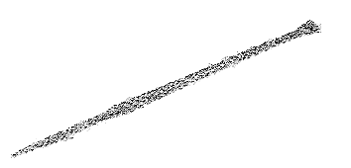 This is a Roman stylus that Roman school children would use like a pen to do their lessons with.

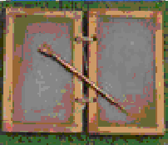 This is a Roman wax tablet that Roman school children would write their lessons on.

They would read scrolls like today’s children read books.

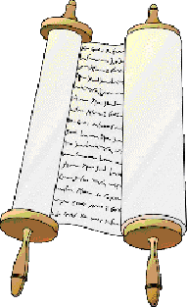 This is a scroll like they would have had in Roman schools

They would also learn to write numbers and do sums. Roman numbers are very different to today’s. Here they are below they are called Roman numerals.

1 = I  2 = II  3 = III  4 = IV  5 = V  6 = VI  7 = VII | 8 = VIII  9 = IX  10 = X  20 = XX  30 = XXX  40 = XL  50 = L | 60 = LX  70 = LXX  80 = LXXX  90 = XC  100 = C  500 = D  1000 = M

After School:

Just like today when Roman children got home from school they played with games and their friends and like today the children had pets.
The toys they played with are almost the same as today. They had kites, hobby horses, balls, board games, little models of people and animals.

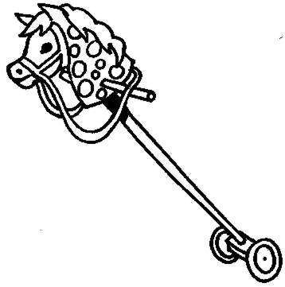 A hobby horse similar to those Roman children played with

They played noughts and crosses and a game like jacks with little bones called knuckle bones. They also had blocks to build small houses. The boys played war with swords and the girls had dolls. The girls also played board and ball games. The board games they played are similar to today’s, like games such as backgammon and draughts.

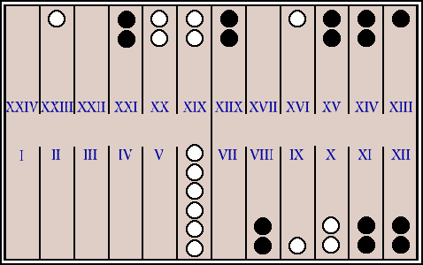 This is a game called tabula which is similar to the game of backgammon we play today.

Poor children had to work quite hard in the family and learning a trade but they still had some time to play. Rich children did not have to work or do any chores around the house as the family had slaves to do the work, so they had plenty of time to play.

Many of the games we play today are very very old games like tag, racing games and hopscotch which started as a training exercise for Roman soldiers.
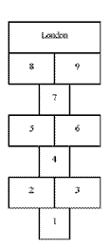The game of hopscotch was first played in Britain by the Romans

Roman children also had pets. Dogs were the most popular and the favourite but they also had little mice that they would hitch tiny carts to. There were other types of pets they had like all sorts of birds and sometimes a rich family may have a monkey. In the later years of the Roman Empire cats also became popular as pets.

Exercise:

1. You are Marcus Flavius and you are the son of a rich family. You are lucky, your parents can afford to pay for you to be educated. Tell the story of your day at school and playing with your toys and brother after school.

...................................................................................................................................................................................................................................................................................................................................................................................................................................................................................................................................................................................................................
Continue the story of Marcus flavius ...................................................................................................................................................................................................................................................................................................................................................................................................................................................................................................................................................................................................................................................................................................................................................................................................................................................................................................................................................................................................................................................................................................................................................................................................................................................................................................................................................................................................................................................................................................................................................................................................................................................................................................................................................................................................................................................................................................................................................................................................................................................................................................................................................................................................................................................................................................................................................................................................................................................................................................................................................................................................
………………………………………………………………………………………………………………….
………………………………………………………………………………………………………………….
2. Did poor children go to school and why?
………………………………………………………………………………………………………………………………………………………………………………………………………………………………………………………………………………………………………………………………………………………
3. What things did poor children have to learn?
………………………………………………………………………………………………………………………………………………………………………………………………………………………………………………………………………………………………………………………………………………………………………………………………………………………………………………………………………… ……………………………………………………………………………………………………………………………………………………………………………………………………………………………………
5. Write your age in Roman Numerals.
…………………………………………………………………………………………………………………
6. Write down the Roman numerals for 10, 20, 30, 40, and 50.
……………………………………………………………………………………………………………………………………………………………………………………………………………………………………
7. Draw a picture of a writing scroll in the space below.

8. Make a list of all the games Roman children played that children today play.

……………………………………………………………………………………………………………….
…………………………………………………………………………………………………………………
………………………………………………………………………………………………………………………………………………………………………………………………………………………………………………………………………………………………………………………………………………………………………………………………………………………………………………………………………………………………………………………………………………………………………………………………………………………………………………………………………………………………………………………………………………………………………………………………………………………………………………………………………………………………………………………………………………………………………………………………………………………………………………………………………..
9. What toys do today’s children have that they did not have in Roman times?

……………………………………………………………………………………………………………………………………………………………………………………………………………………………………………………………………………………………………………………………………………………………………………………………………………………………………………………………………………………………………………………………………………………………………………………………………………………………………………………………………………………………………………………………………………………………………………………………………………………………………………………………………………………………………………………………………………………………………………………………………………………………………………………………………….

