The Roman Army

The Romans invaded so many places because they had such a good army. The army was used to protect Rome and to keep control over the people who they had conquered. Soldiers were in the army for many many years and spent a long time away from their families.
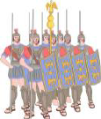 When an auxiliary soldier who was a recruit from conquered lands had been in the army for 25 years he could become a Roman citizen.

The army was organised into groups of troops.

- A legion would have 800 legionnaires, who would be already Roman citizens.
- Each legion would be split up into groups called centuries. In each century were 80 soldiers. The leader of the century was called a centurion.
- These centuries would also be split into smaller groups and they had different jobs to perform. This made the Romans battle tactics more organised.

Roman soldiers were very strong and tough, they had to march over 20 miles a day with heavy things to carry. They had to carry their food, cooking pots, tents and weapons as well as wearing all their armour.

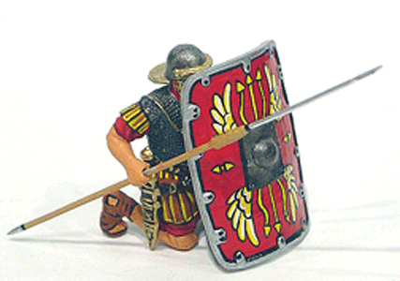

The Roman soldier was very well trained. When their enemies fired their arrows they would put their shields up all around them to protect themselves from the arrows, this was called the 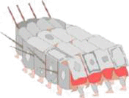 tortoise. They used a short sword as a weapon, daggers for stabbing and a long spear. They wore metal armour and protected themselves with a large shield.

Questions

1. Why did the Roman army invade so many countries?

…………………………………………………………………………………………………………………..

2. How long was the auxiliary soldier in the army for before he could be a Roman citizen?

…………………………………………………………………………………………………………………

3. How many soldiers were in a century?

…………………………………………………………………………………………………………………..

4. What was the name of the leader of the century?

…………………………………………………………………………………………………………………..

5. Why did a Roman soldier have to be tough?

…………………………………………………………………………………………………………………..

…………………………………………………………………………………………………………………..

…………………………………………………………………………………………………………………..

…………………………………………………………………………………………………………………..

…………………………………………………………………………………………………………………..

…………………………………………………………………………………………………………………..

7. How would Roman Soldiers protect themselves from arrows?

…………………………………………………………………………………………………………………..

…………………………………………………………………………………………………………………..

…………………………………………………………………………………………………………………..

…………………………………………………………………………………………………………………..

…………………………………………………………………………………………………………………..

8. What weapons did the Roman Soldier use?

…………………………………………………………………………………………………………………..

…………………………………………………………………………………………………………………..

…………………………………………………………………………………………………………………..

9 Draw a picture of a Roman soldiers shield ?

