Ancient Greeks: Usborne Book Worksheets

Worksheet 1.

You are looking at a history non-fiction book, which is full of information about the Ancient Greeks.

- What can you tell from looking at the covers of the book?
- List the 4 main points of information from the ‘blurb’.
- How many pages are listed on the Contents page?
- Which page is the Glossary on?
- What is a glossary?
- Where is the Index?
- What is the difference between the contents page and the glossary page?
- What is the difference between ‘fiction’ and ‘non-fiction’?

Worksheet 2 (pages 3 – 5)

- Where is Greece?
- What does ‘ancient’ mean?
- Why were boats important?
- Describe the features you can see in the picture on page 3.
- Did everyone live in towns?
- How were Greek houses made?
- Which buildings stood on hills? Why?
- Who did all the housework for rich people?
- Draw the house and the inside rooms on page 4.

Worksheet 3 pages 6 – 7

- Describe the clothes that the Greeks wore.
- What was the name of the long tunics worn by women?
- Which metal was used for jewellery?
- Copy the picture of the woman dressed in her outdoor clothes.
- Label her sun hat and cloak.
- What was fashionable for Greek men to do?

Worksheet 4 pages 8 -9

- List the food that Greek people ate.
- What is the woman in the statue making?
- Can you find out which crops farmers would grow to make bread?
- What are the men doing to the trees in the last picture?
- Which animals were kept for their milk?
- What foods can be made from milk?
- What was lumpy porridge made from?

Worksheet 5 pages 10 – 11

- What is a market?
- Can you name the fresh foods that are being sold in the picture?
- Can you see any other items for sale?
- What is the name for the people that are being sold?
- How did the Greeks pay for their shopping?
- How are the pots made? What are they made from?

Worksheet 6 pages 12 – 13

- Copy the information on page 12.
- Look at the pictures – what is different to a modern day party?
- On page 13 there is an old painting of a musician. Which instruments is she playing?

Worksheet 7 pages 14 – 17

- How do we know the Greeks believed in gods and goddesses?
- Who was Artemis?
- Who was the king of the gods?
- Who was his wife?
- Where did Poseidon rule and live?
- Describe Athene.
- Who was king of the Underworld?
- Why wouldn’t you want to make Zeus angry?
- Why did the Greeks build temples?
- List all the things that happened in a temple.
Worksheet 8 pages 18 -19

- What is the name we give to stories about the heroes and monsters in Ancient Greece?
- Tell the story about Medusa in your own words and pictures.
- Why was Heracles so strong?
- Why do you think these two stories have been chosen for this part of the book?

Worksheet 9 pages 20 – 21

- Where did the Olympic Games start?
- What are they made up of?
- List some of the sports from the ancient Olympics.
- What do you know about the modern Olympic?

Worksheet 10 pages 22 – 23

- Where did the Greeks watch plays?
- What were the seats made from?
- What shape was the space at the front of the main stage?
- Why did the Greek actors wear masks?
- Who was allowed to act in the plays?
- What is a tragedy?
- What is a comedy?

Worksheet 11 pages 24 – 27

- How did Greek soldiers go to war?
- Draw a picture of foot soldiers fighting.
- Describe the things a Greek soldier wore to protect his body.
- Draw a sword and its holder.
- Describe the ways the Greeks went into battle.
- What were ships called?
- Which forms of power were used to make the ships travel through the water?
- Where did the strong fighters come from?

Worksheet 12 pages 28 – 29

- Who was Hippocrates?
- Who studied science and wrote many books?
- What was the name of the woman who wrote poems?
- Which city did Pericles rule?
- Who was the brave soldier riding into battle?
- What do you know about him?
- What is an inventor?

Glossary worksheet page 30

- Copy the words and pictures into your books.
- Which page did each word come from in the book?
- Use the computer to visit the website on page 31.

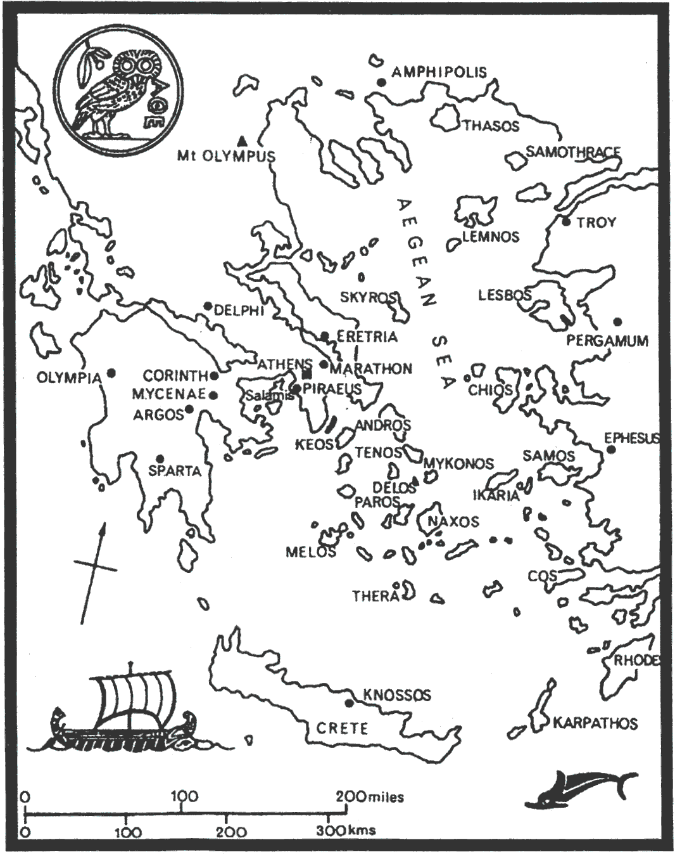

Map from
astronomologer.com

