Florence Nightingale Theme Worksheets, for Grades 2 to 6

Table of Contents
Page 1. Title page and Table of Contents
Page 2. Florence Nightingale Lesson 1 Worksheet, for more advanced students
Page 3. Florence Nightingale Lesson 1 Worksheet, for less advanced students
Page 4. Florence Word and Spelling Card
Page 5. Suggested Vocabulary List for All Florence Nightingale Lessons
Page 6. Florence Nightingale, First Lesson 2 Worksheet, for more advanced students
Page 7. Florence Nightingale, First Lesson 2 Worksheet, for less advanced students
Page 8. Florence Nightingale as A Nurse, Second Lesson 2 Worksheet, for more advanced students
Page 9. Florence Nightingale as A Nurse, Second Lesson 2 Worksheet, for less advanced students
Page 10. Florence and Queen Victoria, Third Lesson 2 Worksheet, for more advanced students
Page 11. Florence and Queen Victoria, Third Lesson 2 Worksheet, for less advanced students
Page 12. Students Give an Account On the Life of Florence Nightingale
Page 13. Mind Mapping -- People Who Lived the Same Time as Florence Nightingale
Page 14. Role Playing on Florence Nightingale, Lesson 8 Activity
Page 15. Mary Seacole, Jamaican Nurse, Lesson 9 Worksheet
Page 16. Lesson 10 Worksheet -- Queen Victoria: Queen of England 1837-1901, Empress of India 1876-1901, for more advanced students
Page 17. Queen Victoria, Lesson 10 Worksheet, for less advanced students
Page 18. Clara Barton, Lesson 11 Worksheet
Page 19. Alexander Graham Bell, Lesson 12 Worksheet, for more advanced students
Page 20. Alexander Graham Bell, Lesson 12 Worksheet, for less advanced students
Page 21. Louis Braille, Lesson 13 Worksheet, for more advanced students
Page 22. Louis Braille, Lesson 13 Worksheet, for less advanced students
Page 23. Lessons 14 to 18 Worksheet -- Mark Twain, Helen Keller, Thomas Edison, Jean François Champollion, and Albert Einstein

Florence Nightingale Lesson 1 Worksheet

Name: ___________________________________ Date: ______________________

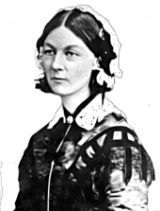
1. What did Florence become famous for? Give two reasons.

--------------------------------------------------------------------------------------
2. When did the Crimean War take place?

Public domain
------------------------------------------------------------------------------------------------------
3. What changes did Florence get the British government to make?

------------------------------------------------------------------------------------------------------
4. What educational system did Florence Nightingale create?

------------------------------------------------------------------------------------------------------
5. Use the following words in sentences to explain their meaning:

Famous ---------------------------------------------------------------------------------------------

Patient ---------------------------------------------------------------------------------------------
Draw a picture of Florence Nightingale

Florence Nightingale Lesson 1 Worksheet

Name: ___________________________ Date____________________
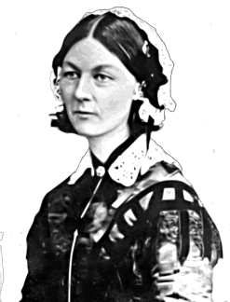
1. Florence was a famous _____________________________.

2. She saved the lives of many soldiers who were

____________________ and _____________________.
Public domain

3. Florence improved conditions of ________________________________.

4. The Crimean War took place in the 18_______s.
Draw a picture of Florence Nightingale

Florence Word and Spelling Card

Teacher prints out a copy for each student of the Florence word and spelling card templates shown below. Students write unfamiliar words they come across during the lessons onto the cards to start building up their own collection of useful words. Students should write the words in pencil so the teacher can ensure correct spelling. Students will find the personal word cards useful for future written assignments.
Name: _______________

Florence
word and spelling card
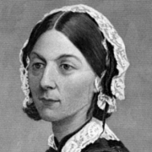
Public domain

Name: _______________

Florence
word and spelling card
Public domain

Suggested Vocabulary List for All Florence Nightingale Lessons

Discuss vocabulary to be used and heard during the lessons.
Add more words to the list.

Vocabulary list suggestions
famous | patients
pioneer | bedridden
reform | advise
battlefield | mentor
Victorian times | objects
landowner | similarities
society | differences
marriage proposal | introduce
sanitize | wounded
infections | estate
nickname | status
organize | wealth
military | gentleman
award | parents

Florence Nightingale, First Lesson 2 Worksheet

Name: ___________________________ Date____________________

Give your answers by writing in full sentences.

1. When was Florence Nightingale born?

--------------------------------------------------------------------------------------
2. Where was she born?

--------------------------------------------------------------------------------------
3. Why was she called Florence?

--------------------------------------------------------------------------------------
4. Where did Florence and her sister grow up?

--------------------------------------------------------------------------------------
5. What did Florence do from a young age?

--------------------------------------------------------------------------------------
6. How old was Florence when she realized she wanted to become a nurse?

--------------------------------------------------------------------------------------
7. How did Florence’s mother feel when Florence told her she wanted to be a nurse?

--------------------------------------------------------------------------------------

Word Bank
unhappy | 16 | Florence | born
Lea Hurst | German | Embley Park | French
Italian | May | sick | people
helped | poor | 1820 | Parthenope

Florence Nightingale, First Lesson 2 Worksheet

Name: _____________________________ Date: __________________

1. Florence was born in ______________________________.

2. Florence is a city in _____________________________.

3. Florence helped _______ and ________ people when she was young.

4. Her mother did not like the idea that she wanted to become a

___________________.

5. Her _______________ taught her to speak German, French, and

______________________.
6. Kaiserwerth is a hospital in a country called ________________.

Word Bank
father | Italy | sick
nurse | Florence | poor
Germany | Italian

Florence Nightingale as A Nurse, Second Lesson 2 Worksheet

Name: ______________________________ Date____________________

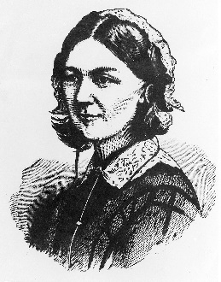
1. Why did Florence go to Kaiserwerth?

-------------------------------------------------------------------
2. In which country was Kaiserwerth?

-------------------------------------------------------------------

Creative Commons CC BY 4.0

3. How did Florence feel when she heard about the soldier dying in the war?

--------------------------------------------------------------------------------------
4. Who did Florence take to Scutari?

--------------------------------------------------------------------------------------
5. What did Florence and her nurses do at Scutari?

--------------------------------------------------------------------------------------
6. Why was Florence called the “Lady with the Lamp”?

--------------------------------------------------------------------------------------

Florence Nightingale as A Nurse, Second Lesson 2 Worksheet

Name: _____________________________ Date: __________________

1. Florence received nursing training at ____________________, a hospital in __________________.

2. Florence was __________and ____________ when she heard that soldiers were dying from poor hospital sanitation conditions.

3. She organized a group of __________ and traveled with them to a hospital called Scutari, in Turkey.

4. Complete the following sentence by adding commas in the right places: Florence ensured that the wounded soldiers had warm blankets clean bedding clean water and healthy food to eat.

5. Why was Florence called the “Lady with the Lamp”?

_________________________________________________________

_________________________________________________________

Word Bank
nurses | unhappy | Germany
visited | Kaiserworth | patients
night | sad | carried
carrying | well | see
being | called

Florence and Queen Victoria, Third Lesson 2 Worksheet

Name: _______________________________ Date_______________________

Answer your questions in full sentences.

1. When did Florence meet Queen Victoria?

--------------------------------------------------------------------------------------
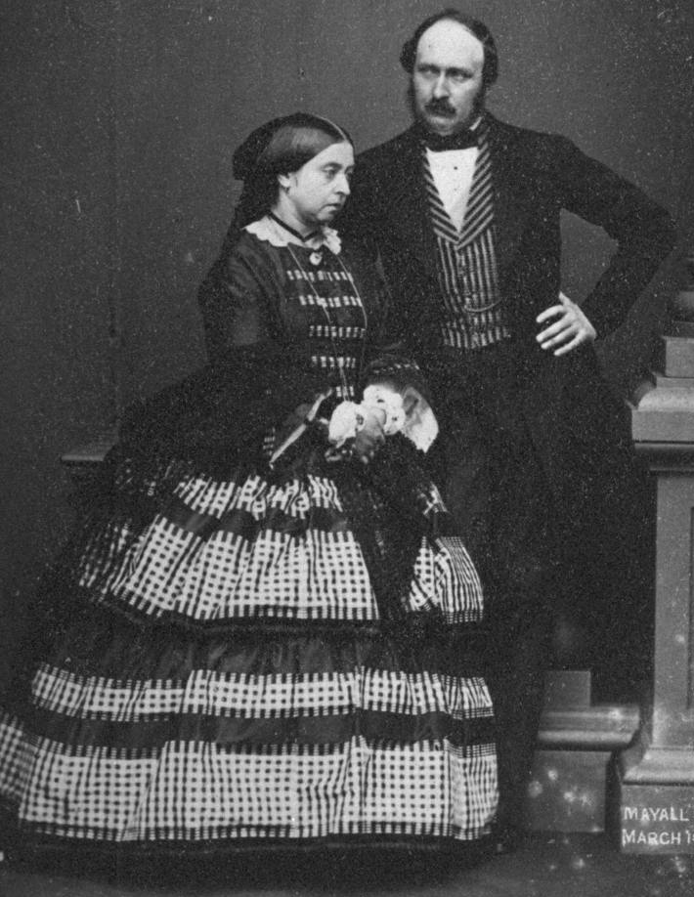
Victoria and Albert
John Jabez Edwin Mayall, Public Domain
2. Who was Queen Victoria’s husband?

--------------------------------------------------------

3. What did Florence discuss with Queen Victoria?

--------------------------------------------------------

--------------------------------------------------------

--------------------------------------------------------

4. Which award did Florence receive from Queen Victoria?

-------------------------------------------------------------------

What caused Florence to become ill and bedridden?

--------------------------------------------------------------------------------------

Florence died on what date? -------------------------------------------------------------------

Florence and Queen Victoria, Third Lesson 2 Worksheet

Name: __________________________ Date__________________

1. Florence met Queen Victoria and Prince Albert in the year ________.

2. Florence discussed ________________________ needed at hospitals with Queen Victoria.

3. Queen Victoria awarded Florence the ____________________

to thank her for all of her ____________________ as a nurse.

4. All the hard work affected Florence’s ________________, and she

became ______________ and ____________________________.

5. Florence died on this date: ____________________, 1919.
Word Bank
Royal Red Cross | hard work | improvements
health | 1883 | ill
August 13 | bedridden

Students Give an Account On the Life of Florence Nightingale

Name: _______________________________ Date______________________

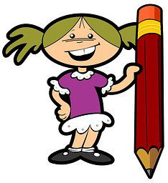
Literacy: Imagine you are a journalist who is going to write a story to tell others about Florence Nightingale. Makes notes as you interview Florence and then write up your own story giving an account of her life as a nurse.

CC0 Public Domain

Assessment: Students complete the following worksheet. What do we know about Florence Nightingale?

Where did she live at different times of her life?

What was she like?

What did she do?

Where did she work?

Who worked with her?

Public domain

Mind Mapping
People Who Lived the Same Time as Florence Nightingale

Name: _______________________________ Date______________________

The rectangle contains the name of Florence Nightingale as the heading to the topic.

Complete the following mind map. Write in the ovals the names of people who lived at the same time as Florence Nightingale.

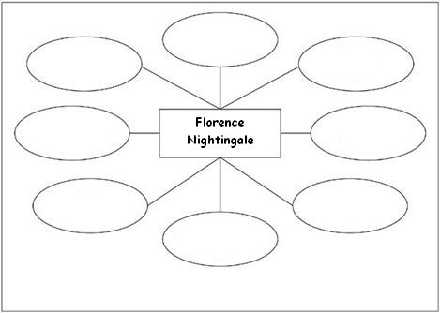

Write a sentence about any three people in the ovals and explain why they were famous.

---------------------------------------------------------------------------------------------------

---------------------------------------------------------------------------------------------------

---------------------------------------------------------------------------------------------------

Role Playing on Florence Nightingale, Lesson 8 Activity

Classmates share their knowledge of Florence Nightingale through drama and role play with the rest of the class at assembly, using work produced over the past seven lessons.

CC0 Public Domain
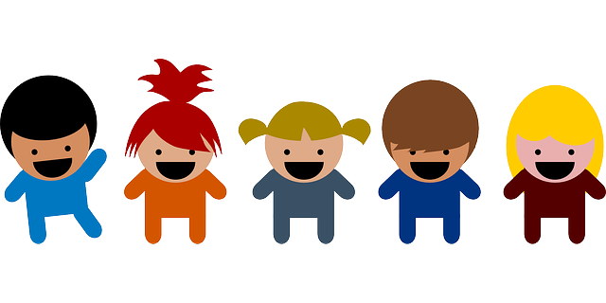
CC0 Public Domain

Preparation: Select props for the assembly. Group the children to work on presenting different aspects of the theme:
- A brief biography of Florence’s life
- Pictures and paintings of Florence’s life
- Pictures of the hospital where she and her nurses worked
- Stories from the nurses who worked with her
- Two children to introduce the sound recording of Florence
- People alive at the same time as Florence Nightingale
Children can use drawings to illustrate their presentations, and each child in the class should be given an opportunity to participate in their group’s presentation.

Mary Seacole, Jamaican Nurse, Lesson 9 Worksheet

Name: _______________________________ Date______________________

Draw a picture of Mary Seacole.

Write a paragraph about Mary Seacole.

----------------------------------------------------------------------------------------------------

----------------------------------------------------------------------------------------------------

----------------------------------------------------------------------------------------------------

----------------------------------------------------------------------------------------------------

----------------------------------------------------------------------------------------------------

----------------------------------------------------------------------------------------------------

----------------------------------------------------------------------------------------------------

----------------------------------------------------------------------------------------------------

----------------------------------------------------------------------------------------------------

----------------------------------------------------------------------------------------------------

Lesson 10 Worksheet
Queen Victoria: Queen of England 1837-1901, Empress of India 1876-1901

Name: _______________________________ Date______________________

Read the passage and answer the questions below.

Victoria was born at Kensington Palace in London on the 24th of May 1819. In 1837, at the age of 18, she became Queen of the United Kingdom of Great Britain and Ireland. She later married Albert, a prince from Germany. They had nine children.

Albert died of typhoid when he was 42. Queen Victoria mourned the death of Albert all her life and wore black clothes until the end of her reign.

Victoria was the first monarch to live in Buckingham Palace. She was queen for 63 years and 7 months.

1. Queen Victoria was Queen of England from ________ to ________ and Empress of _____________ from 1876-1901.

2. Victoria was born at _________________________ in London.

3. She was born on the _________ day of May in the year __________.

4. How old was Victoria when she became Queen?

________________________________________________________

5. She later married ___________, a prince from _______________. They had nine children.

6. Albert died of _______________________ when he was 42. Queen Victoria mourned the death of Albert all her life and wore black clothes until the end of her reign.

7. Victoria was Queen for ____________ years and ______________ months.

Queen Victoria, Lesson 10 Worksheet

Name: __________________________ Date__________________

Draw a picture of Queen Victoria.

Write a paragraph about Queen Victoria

--------------------------------------------------------------------------------------

--------------------------------------------------------------------------------------

--------------------------------------------------------------------------------------

--------------------------------------------------------------------------------------

--------------------------------------------------------------------------------------

--------------------------------------------------------------------------------------

--------------------------------------------------------------------------------------

Clara Barton, Lesson 11 Worksheet

Name: _______________________________ Date______________________

Draw a picture of Clara Barton.

Write a paragraph about Clara Barton.

----------------------------------------------------------------------------------------------------

----------------------------------------------------------------------------------------------------

----------------------------------------------------------------------------------------------------

----------------------------------------------------------------------------------------------------

----------------------------------------------------------------------------------------------------

----------------------------------------------------------------------------------------------------

----------------------------------------------------------------------------------------------------

----------------------------------------------------------------------------------------------------

----------------------------------------------------------------------------------------------------

----------------------------------------------------------------------------------------------------

Alexander Graham Bell, Lesson 12 Worksheet

Name: _______________________________ Date______________________

1. Alexander had three professions: _____________________, engineer, and

______________________.

2. He was born in ____________________, a city in Scotland, on the date

______________________.

3. He died on August 2, 1922, at the age of ______________.

4. Both his _______________ and his _______________ were deaf.

5. One of Alexander Graham Bell’s best known inventions was the _______________________________.

6. He also helped create the National Geographic ______________.
Word Bank

telephone | mother | scientist
Edinburgh | Scotland | engineer
wife | society | deaf
inventor

Alexander Graham Bell, Lesson 12 Worksheet

Name: ____________________________ Date____________________

Read the following passage and answer the questions below. Write in full sentences.

Alexander was a scientist, engineer, and inventor. He was born in Edinburgh, Scotland, on March 3, 1847. He died on August 2, 1922, at the age of 75. Both his mother and his wife were deaf. That inspired and influenced a lot of his work. Bell later moved with his family to Canada and the United States.

He began working with deaf people, and in 1872 founded a school for the deaf. Alexander and Helen Keller met each other at this school.

One of Alexander Graham Bell’s best known inventions was the telephone. He also helped create the National Geographic Society.

1. Alexander was an engineer and inventor. What else did he do?

--------------------------------------------------------------------------------------
2. Where was Alexander Graham Bell born?

--------------------------------------------------------------------------------------
3. How old was he when he died?

--------------------------------------------------------------------------------------
4. Two if his family members were deaf. Who were they?

--------------------------------------------------------------------------------------
5. What organization did Alexander help create?

--------------------------------------------------------------------------------------
6. What was Alexander’s best known invention?

--------------------------------------------------------------------------------------

Louis Braille, Lesson 13 Worksheet

Name: _______________________________ Date______________________

Louis pierced one of his eyes with an awl. The accident caused an infection that left him completely blind.
Make a drawing of an awl

Below is an example of Braille. Write your name in Braille.
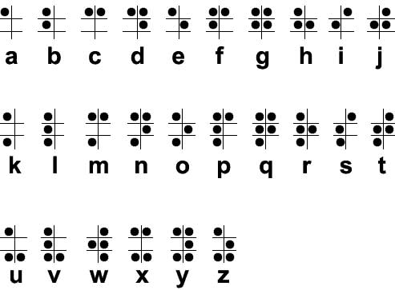
Public domain

Your name in Braille:

--------------------------------------------------------------------------------------

Louis Braille, Lesson 13 Worksheet

Read the passage below. Then write a letter to a friend. In the letter, tell the friend what you learned about Louis Braille.

Louis Braille developed a system that enabled blind people to read. He was born in 1809, in Paris, France. His father, a shoemaker, used various tools. One tool was a sharp-pointed awl. Louis picked up the awl. It slipped and pierced one of his eyes, causing an infection that left Louis completely blind.

He was 10 years old when he went to a special school for blind children in Paris. At the school, students were taught to read and write using a system of raised letters. Louis found the system very hard to use, as it was difficult to tell the letters apart. Charles Barbier, a captain in the French army, paid a visit to the school, as he had developed a system that allowed soldiers to read messages in the dark. The system consisted of a series of raised dots. Louis adapted that system so it could be used by blind people.

Louis became a teacher. It was only after his death that the Braille system was adopted. But it is used in almost every country in the world today. Below is an example of Braille. See if you can write your name in Braille.

Public domain

Your name in Braille:

--------------------------------------------------------------------------------------

Lessons 14 to 18 Worksheet
Mark Twain, Helen Keller, Thomas Edison,
Jean François Champollion, and Albert Einstein

1. Mark Twain, author of ________________________________

and “Huckleberry Finn” was born in _____________________, a city in Missouri.

2. Helen Keller paved the way for ____________________ people.

3. Anne Sullivan taught Helen how to ______________________.

4. Thomas Edison ___________ the electric _______________________.

5. He invented over ____________________ (how many?) items.

6. Jean François Champollion was the first ____________________ to

decipher _____________________________ hieroglyphics.

8. _______________________, who discovered the theory of relativity, was one of the world’s most important scientists.
Word Bank

Albert Einstein | Egyptian | 1,000
invented | Westerner | light bulb
communicate | deafblind | Tom Sawyer
St. Petersburg

Copyright 2015 by Maria Elizabeth Lotter

