Facts!

The old city of Rome stood where Rome (the capital of Italy) is today.

Can you see where Rome is on the map?

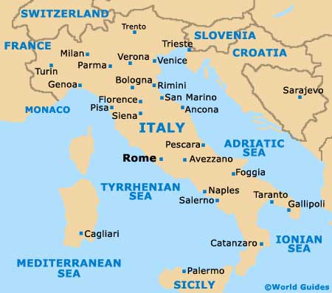
Of all the people in Ancient Rome, nearly half of them were slaves.
In Ancient Rome, only boys went to school. Girls stayed at home.
In Ancient Rome, only boys went to school. The girls stayed at home.
The Ancient City of Rome began as a small village in 753 BC

One of the emperors of Rome built a wall between England and Scotland. This wall was 72 miles long! This emperor was called Hadrian.
Even though he was in charge of Ancient Rome, Hadrian was born in Spain.
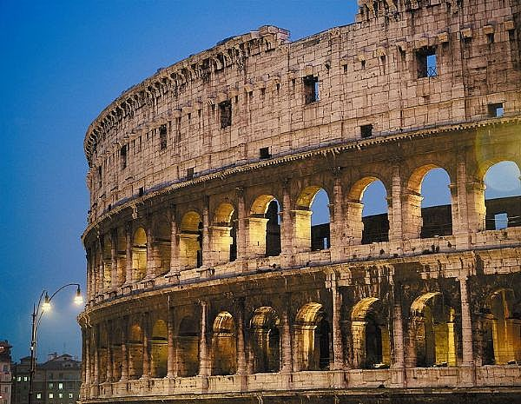

The City of Rome

The City of Rome was started in 753 BC.

Some people say that they City started as some small wooden houses.

Other people say that a man called Romulus killed his twin brother Remus and built a city called ‘Rome’.

At first, Rome was ruled by a King.
Later, it was ruled by 100 very powerful families.

Rome became one of the strongest cities in the World.

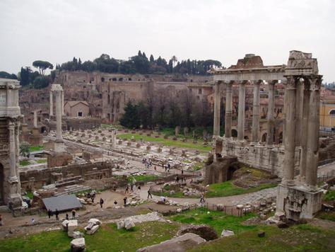

Emperor of Rome

Julius Caesar took charge of Rome in 49 BC. He was murdered in 44 BC.

The next people to rule Rome were Augustus Caesar and Mark Anthony. These 2 men were friends at first, but then they had a big row.

The argument between Augustus Caesar and Mark Anthony:

Augustus told Mark to take over Egypt. When Mark got to Egypt, he did not take it over because he fell in love with the Queen of Egypt. Her name was Cleopatra. Augustus sent an army to fight Mark. Mark Anthony lost this battle and was killed. Cleopatra made a poisonous snake bit her so that she would die before she was caught by the Romans.

Augustus then became the first Roman Emperor.

