Just like we do, Romans played board games.

There have even been some counters and boards from Roman times found today.

Games could be played in pairs or in groups.

Romans also enjoying hunting in their spare time.

Romans hunted and killed animals for fun as well as for food.

The Romans enjoyed hunting so much that they brought deer to Britain so that they could hunt them!
The Gladiators

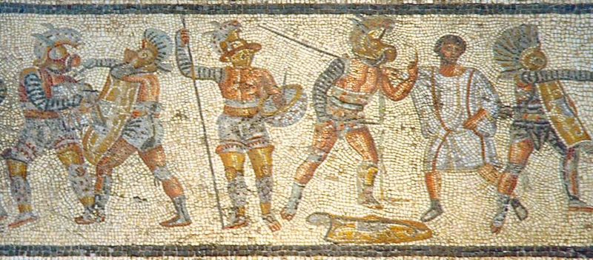

Roman Gladiators fought with each other in Amphitheatres.

They fought so that an audience could watch them.

Sometimes, Gladiators were made to fight with lions and bears.

Often, two Gladiators would fight until one of them had been killed.

If a Gladiator lost but was not killed, the audience would decide if he should live or die.
The Amphitheatre

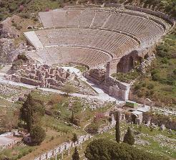
These are pictures of Roman Amphitheatres.

An Amphitheatre is what we now call a Theatre – somewhere we go to watch a show or a concert.

The Amphitheatre cost nothing to get in to, and could hold thousands of people at a time.

Although Romans went to see funny drama shows in Amphitheatres, some of the things which took place were really terrible…

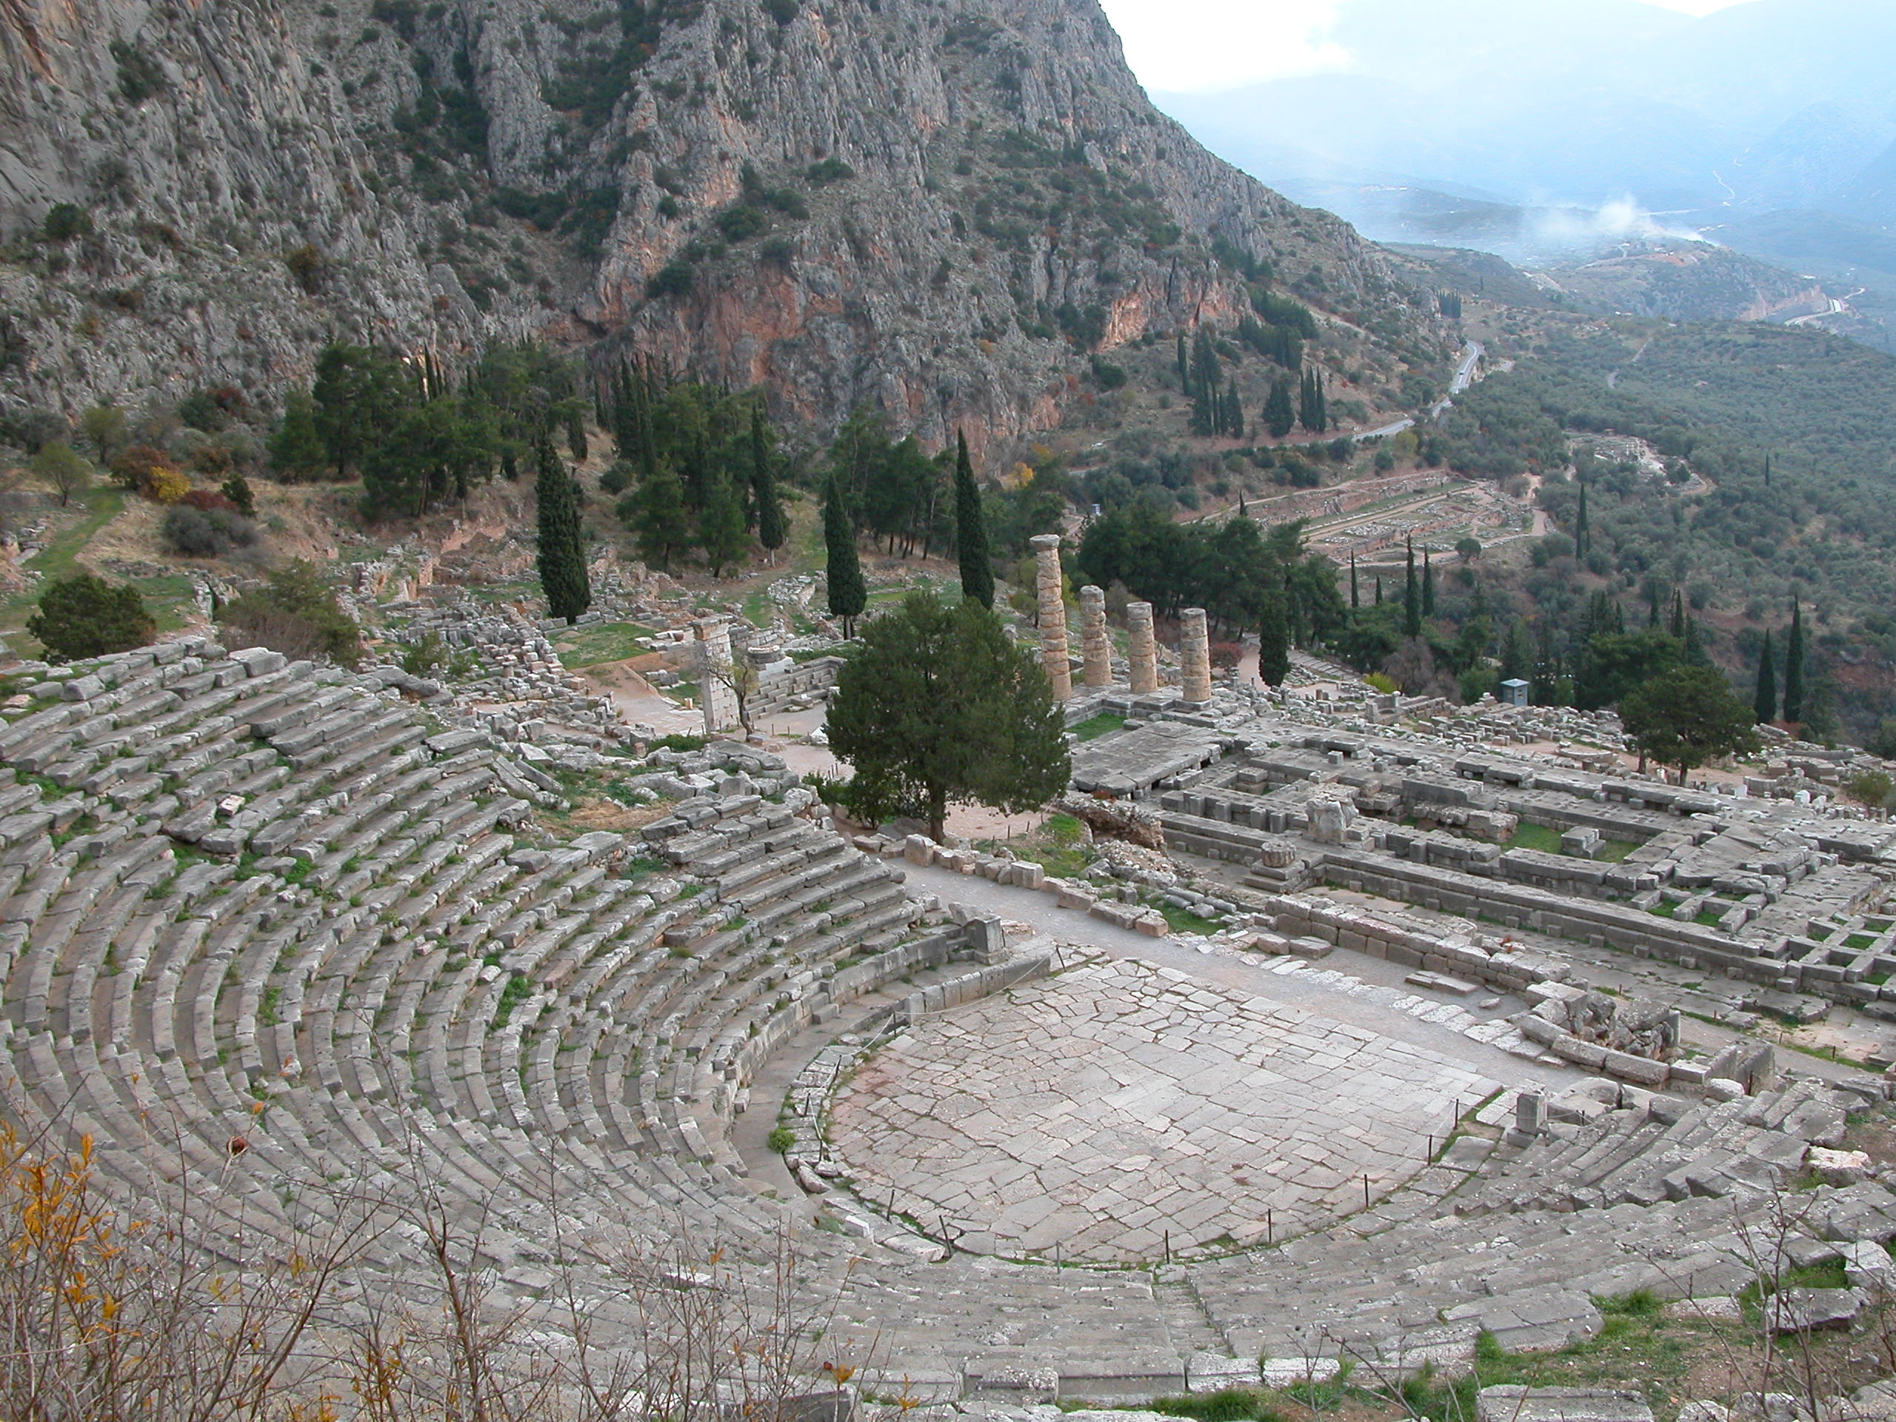
The Baths

Another activity that Romans did in their spare time was to go to the Baths.

There are still some Baths left from Roman times in England today. They are in a place called…. Bath!

This is a picture of the Roman Baths in England.

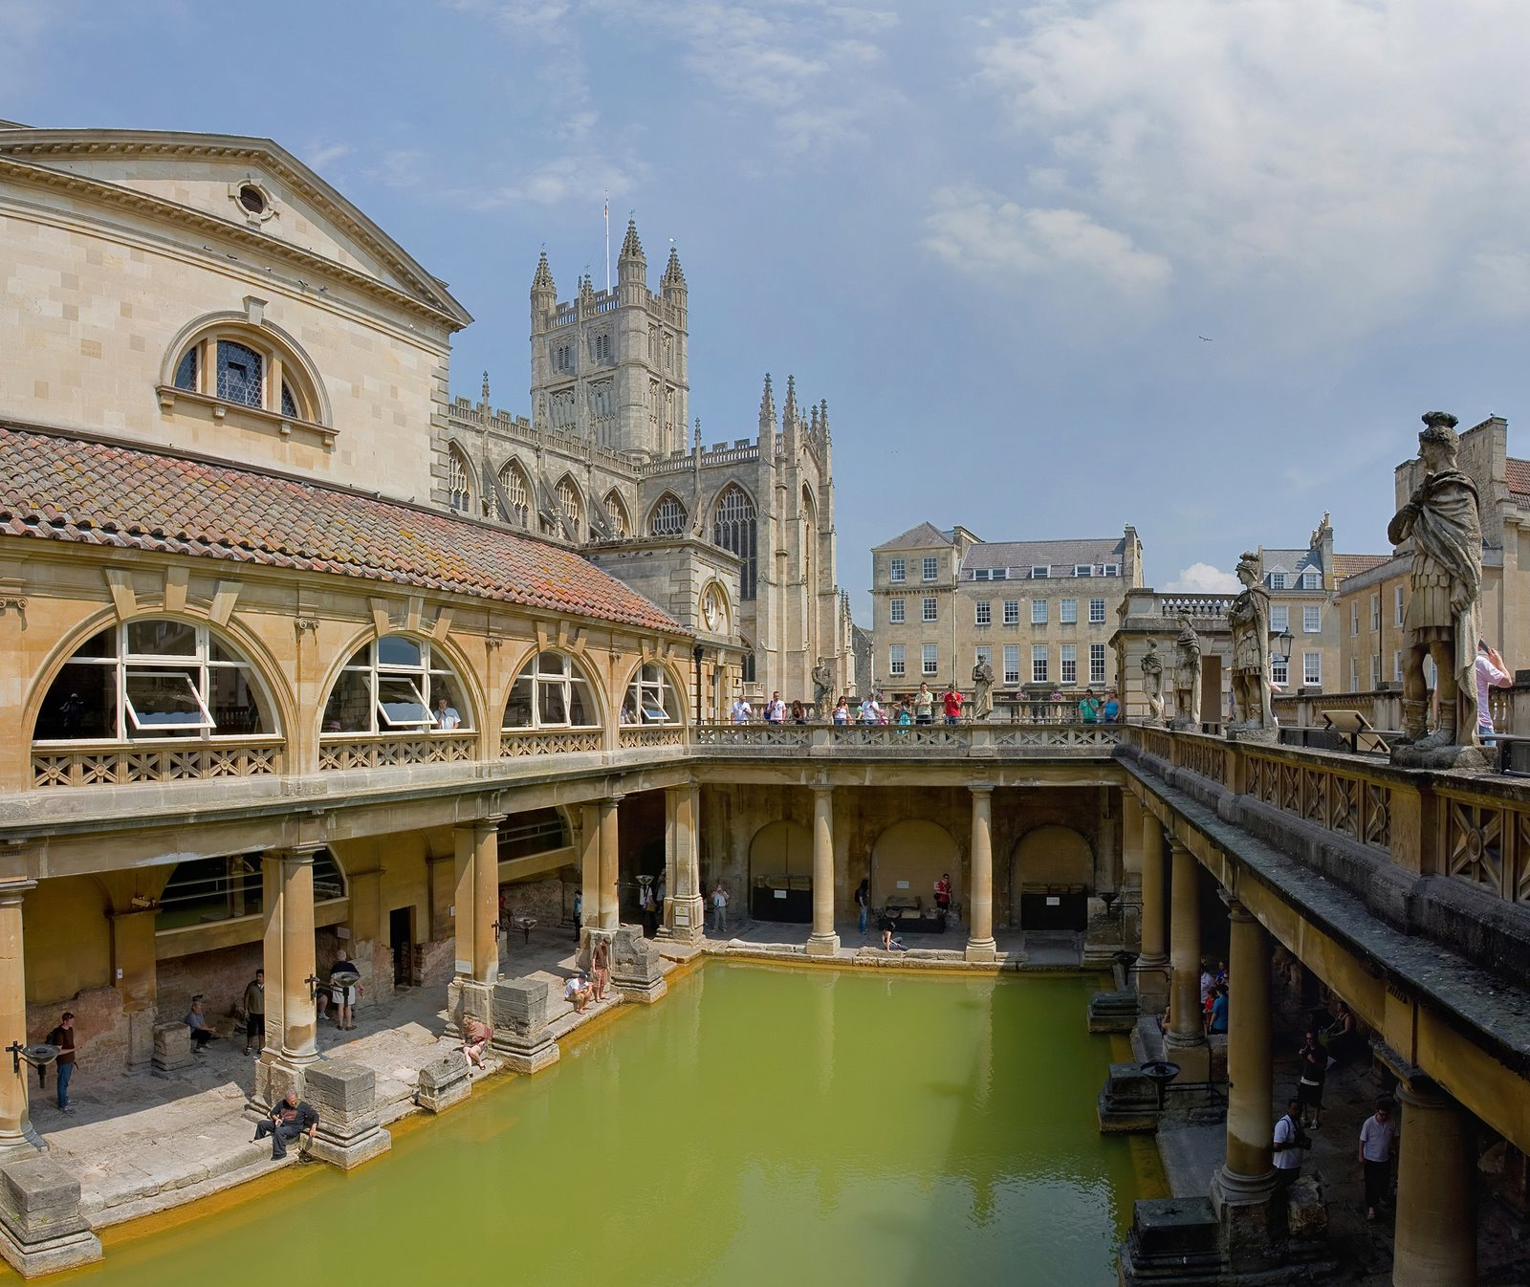

Romans went to the baths to get clean. This is what they would do when they got there.

- Some exercises
- Some swimming
- Sit or stand in some very hot rooms (to sweat the dirt off)
- Have their skin scraped with a strigil (a metal stick)
- Go for a swim in a VERY cold pool!

The Romans liked going to the baths because they could relax and meet lots of people to talk to.
In your group, answer the following questions:

How much did it cost to get into the Amphitheatre?

Where are the famous Roman Baths in Great Britain?

Why did the Romans hunt animals?

What animals did Roman Gladiators sometimes have to fight?

Why did Romans stand in very hot rooms when they were at the baths?

What other things did Romans do in the baths?

