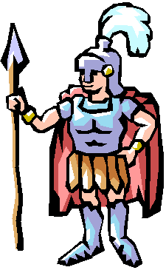
Research for my work on the Romans

Who were the Romans?

How did the Romans keep clean?

What clothes did the Romans wear?

What did the Romans eat?

How did they cook and prepare their food?

Where did the Romans live? What were their homes like?

The Romans
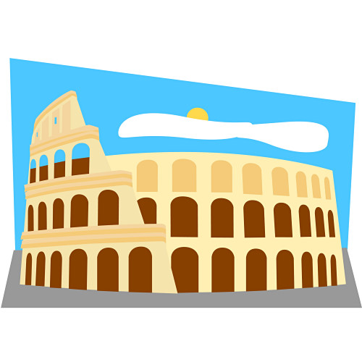

Clothes and Cleanliness

Food

Roman Homes

