The Normans
1066AD

The Tudors
1485-1603AD

First Car in 1885

World War II
1939-1945AD

Christopher Columbus Discovers America – 1492AD

Ancient Egyptians
3500BC-30BC

The Romans
753BC-455AD
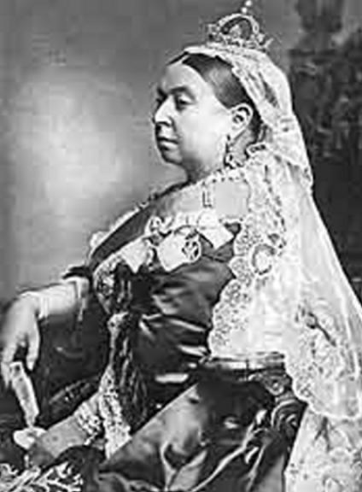

The Victorians
1837-1901AD


Ancient Greece
800-100BC

