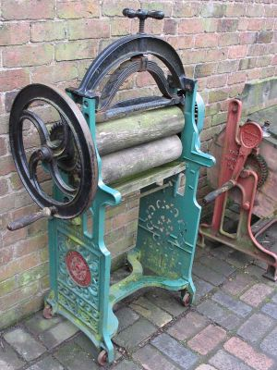

Mangle

Used to dry clothes by squeezing all of the water out.

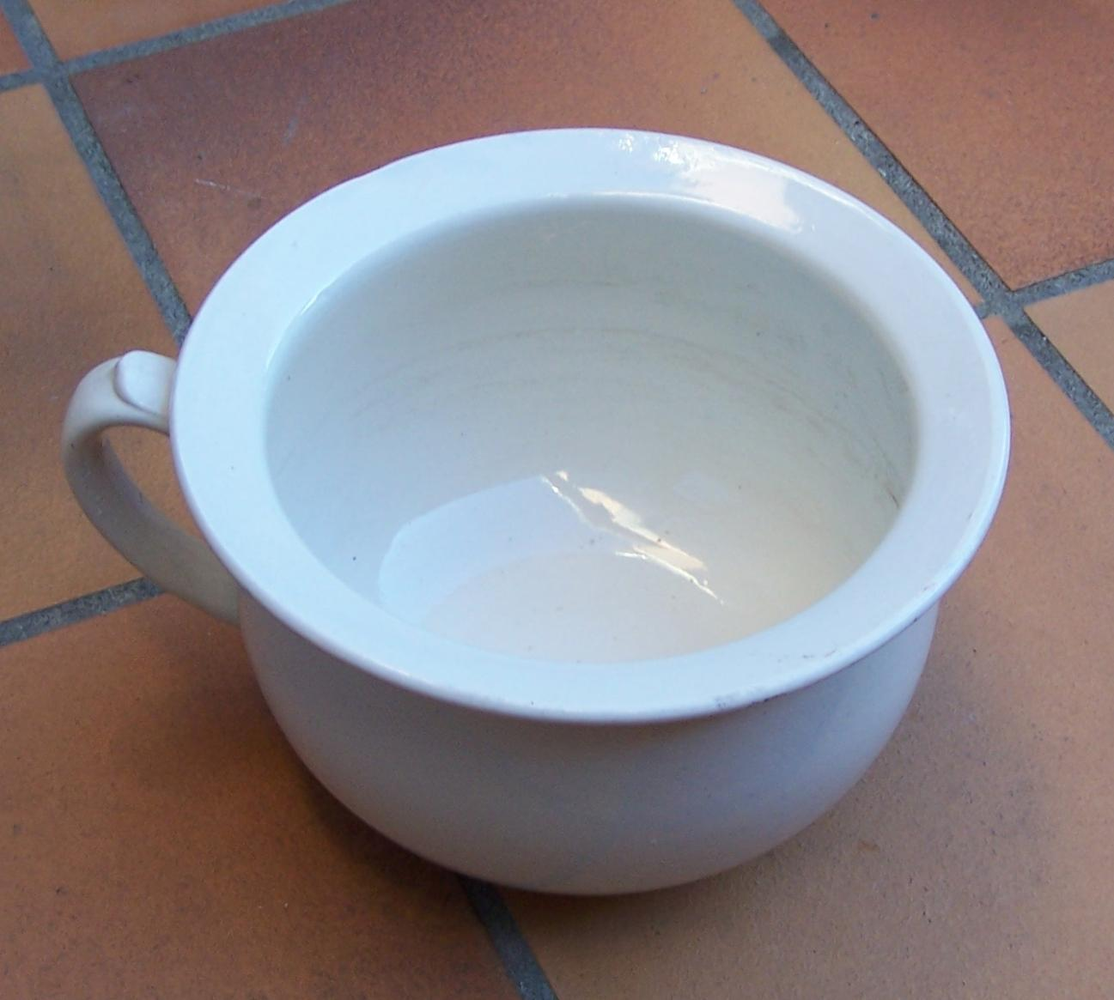

Chamber Pot

Used instead of a toilet during the night.
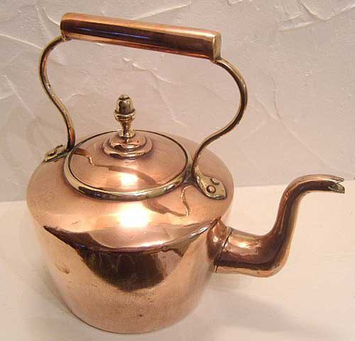

Copper Kettle

Heated up on the stove to make a cup of tea.

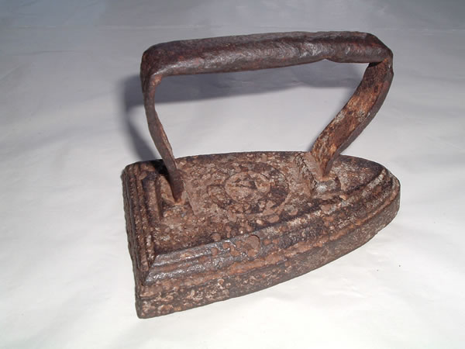

Iron

Heated on the stove to get rid of creases in clothes.

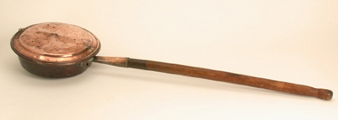

Bed Warmer

Used instead of a hot water bottle to warm up the bed.
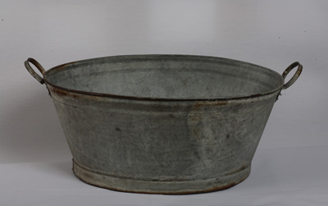
Bath tub

Used when the Victorians wanted to have a proper wash.
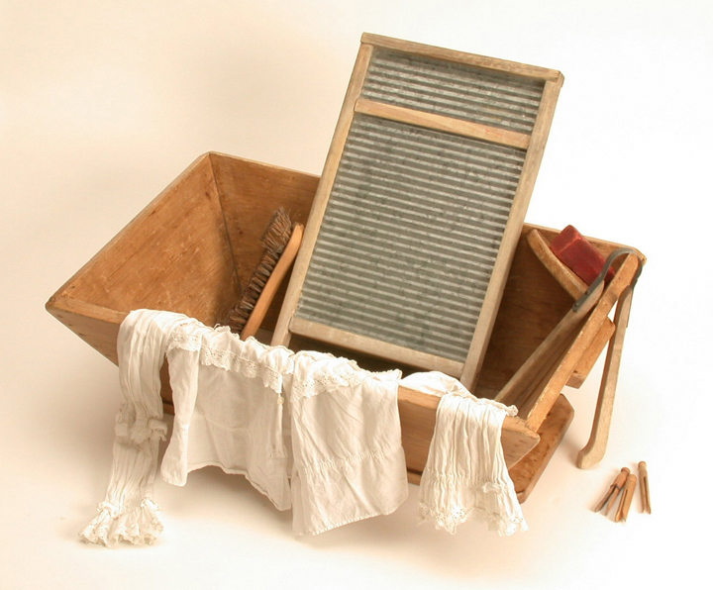

Washboard

Used to wash and scrub dirty clothes.

