You will be completing a project about Victorian children. I have collected all the books you might find useful from the school library and put them in the classroom. You may also use the internet to help you with your research. But remember… WRITE IN YOUR OWN WORDS; DO NOT COPY FROM BOOKS OR THE INTERNET! Take care with presentation, handwriting, spelling, grammar and punctuation.

Front Cover
Colour the title neatly. Write your name on the cover. Decorate the front cover with appropriate drawings and pictures (Queen Victoria, Prince Albert, Victorian people, Victorian schools, Victorian toys, Victorian inventions etc).

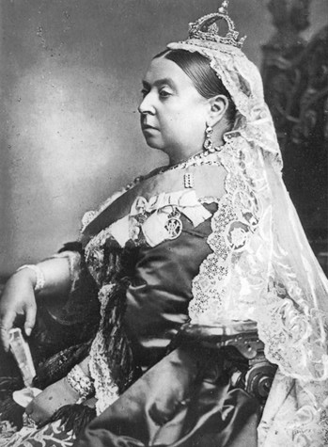
Queen Victoria
Colour the title neatly. Find out some interesting information about Queen Victoria and Prince Albert (using the books and the internet). Write about them on the lines provided.

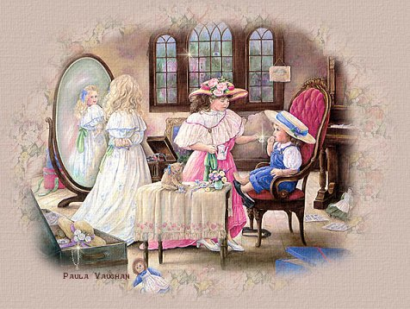
Rich Victorian Children
Colour the title neatly. Find out what rich Victorian
children used to wear, what toys they used to play
with and what their homes were like. Draw a
picture of rich Victorian children in the box. Then
write about the lives of rich Victorian children on
the lines. Where did they live? What did they wear?
What toys did they play with? What jobs did their
parents do? How were they educated?

Poor Victorian Children
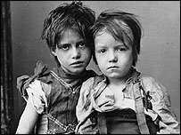
Colour the title neatly. Find out what poor Victorian
children used to wear, what toys they used to play
with and what their homes were like. Draw a picture
of poor Victorian children in the box. Then write
about the lives of poor Victorian children on the
lines. Where did they live? What did they wear?
What toys did they play with? What jobs did their
parents do? Did they go to school? Did some
children work? What jobs did they have to do?

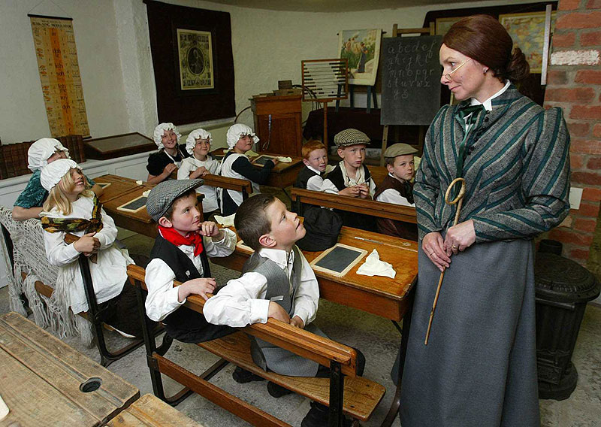
School
Colour the title neatly. Draw a typical Victorian classroom. Write about what school was like in Victorian times. What lessons did the children have? What were the teachers like? What punishments did the teachers give the children? What are the differences and similarities compared to school today?
Toys
Colour the title neatly. Draw some pictures of the toys Victorian children played with. Then write about them on the lines. What were the toys made of? Did rich children have different toys to poor children? What toys did boys like to play with? What toys did girls like to play with? What are the differences and similarities compared to the toys you have today?

