The Victorians

- How old was Queen Victoria when she was crowned Queen? (Tick one box)

A. 19 Years B. 18 Years C. 20 Years

/1

- In what year did Queen Victoria die?
(Tick one box)

A. 1910 B. 1901 C. 1899

/1

- What was the name of Queen Victoria’s husband?

___________________________________________ /1

- Look at the picture below. This shows Queen Victoria in the earlier part of her reign. What major event in 1840 caused her to wear black for the rest of her life?

___________________________________________ /1
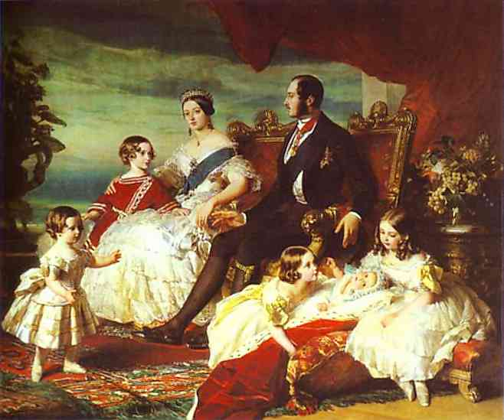

Page Total /4
- Name three jobs that many poor children living in Victorian times had to do.

/3

- Describe two dangers associated with the jobs that children often had to do.
/1

/1

- In 1833, the Government began passing laws to improve the working lives of children. These laws were known as:
(Tick one box)

  - The Working Laws

  - The Worker’s Act

The Factory Acts /1

- Why do you think they were named this?

/2

Page Total /8
- Write ‘true’ or ‘false’ next to the following statements.
All Victorian children owned a rocking horse.
Victorian children would often play with marbles.
Many Victorian children made their own toys.
A ‘penny-farthing’ was a Victorian method of transport.
Cricket and rugby were not played during Queen Victoria’s reign.

/5

10. Draw four lines to match the following definitions to the correct type of school.

A local woman held classes in a room of her house.
These were church schools, which used one teacher and lots of monitors to teach hundreds of children at one time.
Classes were held at the factories during working hours.
These were charity schools for the very poorest children.
National School
Factory School
Dame School
Ragged School

/4

Page Total /9
11. Explain what is meant by the phrase, ‘The 3 Rs.’

/2

12. Write ‘true’ or ‘false’ next to the following statements.
Victorian children would write on slates.
Victorian children would use plastic cubes to help them learn their times tables.
A long wooden stick was used to hit children as a punishment.
If a child got their work wrong, they were made to sit in a corner wearing a tall cone-shaped hat.
Victorian children would use calculators to help work out more complicated sums.

/5

13. What is a census?

/2

14. In Britain, how often is a census taken?
(Tick one box)

Every 100 years
Every 5 years
Every 10 years /1

Page Total /10
15. During Victoria’s reign, many people moved from the countryside to the towns. Give one possible reason for this.

/2

16. Give two reasons why railways were unpopular.

/2

17. Give two benefits of having a railway. (Two good things about railways)

/2

18. List three ways that Britain changed during Queen Victoria’s reign.

/3

Page Total /9

