Name: Date:

Colour in the face / draw a face onto the blank one, which best describes what you have learnt in ICT
I Can:
Use ICT to select and control sounds
Use ICT to organise and reorganise sounds
Use icons to arrange musical phrases
Understand that electronic and live sounds can be combined in a performance
Use ICT to create, organise and reorganise sounds
Identify different ways sounds are used to accompany a song
Learn a song and sing it musically
Recognise musical phrases that could be used as an introduction, middle and ending
Recognise and perform rhythmic patterns
Fit different rhythmic patterns together
Recognise how music can reflect different ideas and moods
Compose a piece of music using the computer, using patterns in the rhythm and with the mood I have chosen.
STRINGS

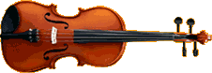
VIOLIN

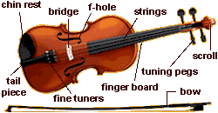

VIOLA

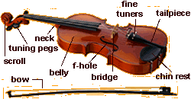

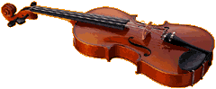

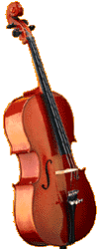
CELLO

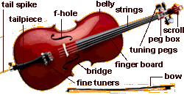

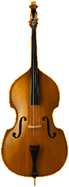
Double Bass
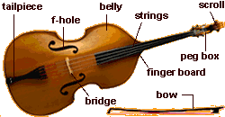

WOODWIND
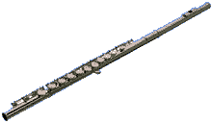
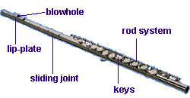
FLUTE


CLARINET
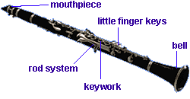

Oboe

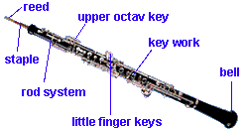

Bassoon

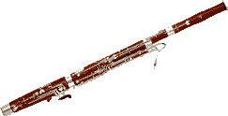
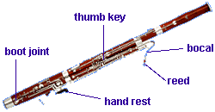

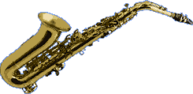
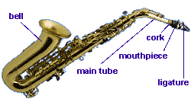
Saxophone

BRASS

Trumpet
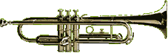

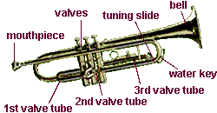

French Horn

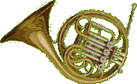
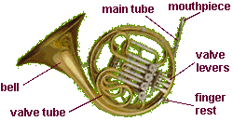

Trombone

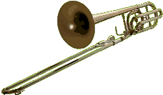
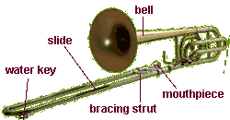

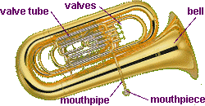
Tuba

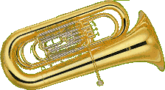

Percussion

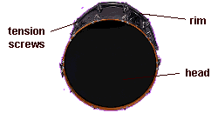
Bass Drum

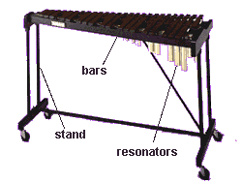
Xylophone

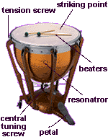
Timpani

