ICT Lesson 4

What is this?

Lots of other items can be used with a computer. Let’s look at some of them.
Here are some pictures. Try to work out what each item is called.

Now let’s see if you can copy and paste the correct label to the text box below each picture.

Reminder: Highlight the word you need and use the copy icon. Make sure you click in the text box before you use the paste icon!

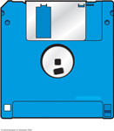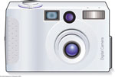

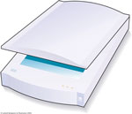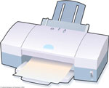

Flatbed scanner digital camera floppy disc inkjet printer

Type your name and date in this last box.

Save this work to your Good Work folder. Name the file ICT Lesson 4.
Ask the teacher if you can print your work today. EPScott2005

