 | Microsoft Word buttons (keyboard shortcuts)
 | New file | (Ctrl+N)
 | Bold text | (Ctrl+B)
 | Align left text | (Ctrl+L)
 | Centre text | (Ctrl+E)
 | Justify text | (Ctrl+J)
 | Cut text | (Ctrl+X)
 | Copy text | (Ctrl+C)
 | Paste text | (Ctrl+V)
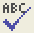 | Spellchecker | (F7)
 | Undo last action | (Ctrl+Z)
 | Print preview
 | Print | (Ctrl+P)
 | Save | (Ctrl+S)

Word Processing
Task 1

1. Write two sentences, in your own words, about a hobby or interest. Give your words a heading at the top of the page.

2. Open Microsoft Word: | 

3. Now type your words into the computer:

???? | 
????

4. Use the spell check to check through your work and correct any mistakes: | 

5. Save your work: | 

6. Close Microsoft Word:

Word Processing
Task 2
Design a poster

1. Design a poster. Give your poster a heading at the top of the page. | 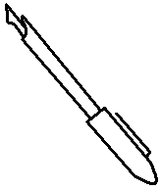

2. Open Microsoft Word:

3. Now type your words into the computer: | 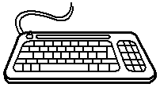

4. Use the spell check to check through your work and correct any mistakes:

5. Change all the words to a different font:

6. Change all the words to a different size:

7. Change all the words to a different colour: | 

8. Save your work:

9. Close Microsoft Word:

Word Processing
Task 3
Design an advert

1. Design an advert with at least two lines of words. Give your advert a heading at the top of the page.

2. Open Microsoft Word:

3. Type your words into the computer:

4. Select (highlight) your second sentence: | 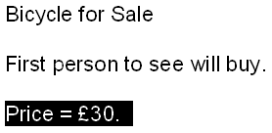

5. Click on Copy: | 

6. Move the cursor so that it is under your heading: | 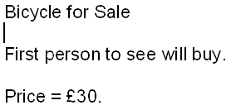

7. Click on Paste: | 

Extension activities:

1. Use the spell check to check through your work and correct any mistakes:

2. Change all the words to a different font:

3. Change all the words to a different size:

4. Change all the words to a different colour:

5. Save your work
a. Click on Save:
b. Give your work a name, such as advert:
c. Click on Save:

6. Close Microsoft Word:

Word Processing
Task 4
Insert a Clip Art picture

1. Write two sentences about what you did last weekend. Give your words a heading at the top of the page.

2. Open Microsoft Word:

3. Type your words into the computer:

4. Insert a Clip Art picture

a. Click on Insert:
b. Click on Picture:
c. Click on Clip Art:
d. Type a word, such as computer, into the Clip Art search box: | 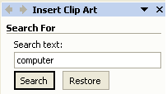
e. Click on Search:
f. Click on a Clip Art picture to insert it: | 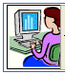

Extension activities:

1. Use the spell check to check through your work and correct any mistakes:

2. Select (highlight) your bottom sentence: | 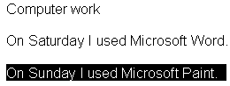

3. Click on Copy:

4. Move the cursor so that it is under your heading: | 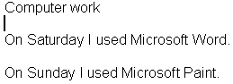

5. Click on Paste:

6. Save your work
a. Click on Save:
b. Give your work a name, such as last weekend:
c. Click on Save:

7. Close Microsoft Word:

Word Processing
Task 5

1. Open My Documents:

2. Open the work (file) you saved last week: | 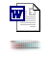

3. Print your work: | 

4. Close Microsoft Word:

5. Close My Documents:

