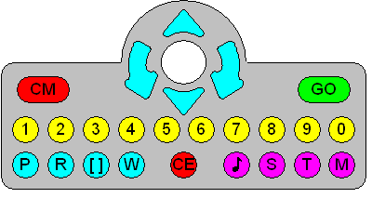

= CM
= FORWARD
= BACKWARD
= LEFT
= RIGHT
 = GO


