Using Clip Art | Name
Using Clip Art | Date
You can use Clip Art to bring your word processing alive and make it eye catching. Follow the instructions below to add Clip Art to your work.

(1) Open a new file so that you have a blank page to work with.
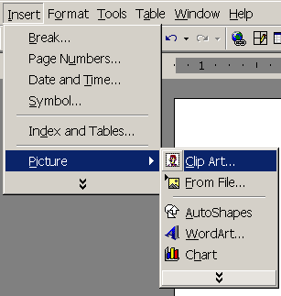
(2) Click the Insert Clip Art button on the Drawing toolbar
OR click Insert on the Menu bar and choose Picture/Clip Art.

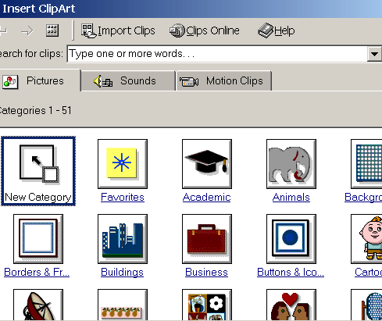
(3) The Clip Art Window
will appear.
Click on a category to view Clip Art within.

OR type the name of an image you are looking for in the Search for clips box, and hit the Enter key on the keyboard. For example, if you type toads, the Clip Art gallery will portray all Clip Art images related to toads
(4) To insert the clip onto your page, click on the image and click the first button on the pop-up menu.
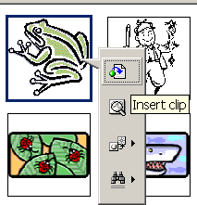

(5) To move back and forth through clipart images, click the left and right arrow buttons at the top left corner of the Clip Art window.
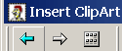
(6) Editing a Graphic
Activate the image you wish to edit by clicking on it once with the mouse. Nine handles will appear around the graphic. Click and drag these handles to resize the image. The handles on the corners will resize proportionally while the handles on the straight lines will stretch the image. More picture effects can be changed using the Picture toolbar. The Picture toolbar should appear when you click on the image. Otherwise, select View|Toolbars|Picture from the menu bar to activate it.
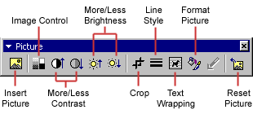

Once you are happy with your pictures type in the text.

You may want to rearrange your picture once you have done this.

