Y4 ICT – Branching databases
L.O – To learn to search a computerised branching database.

Strange Animal information sheet

Use the branching database on the strange animals to find out what their proper name is and find some information on them.

Animal | Name | Any other information

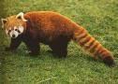
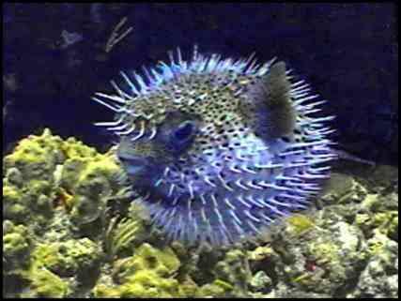
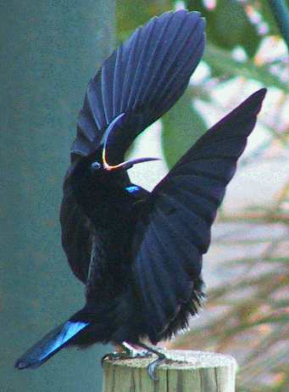
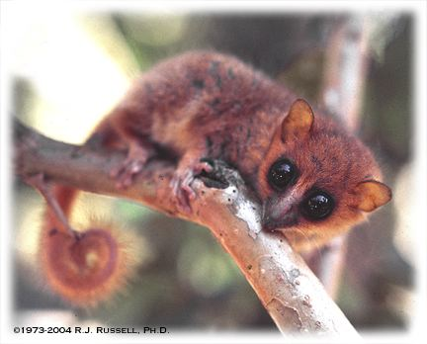
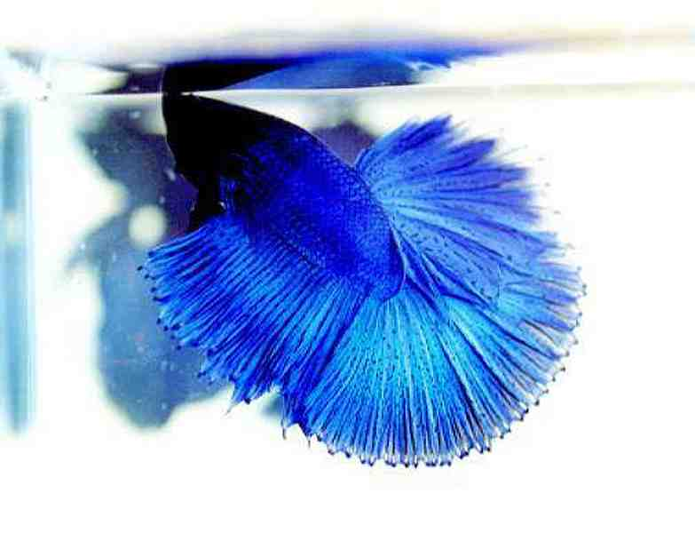

How well do you think you can search a branching database?

