Branching Databases

If you finish your work try create a Branching Database of
clothing.


Shoes, coat,
gloves, skirt,
scarf, socks,
hat and tights.

Task 2

Create a Branching Database using these different types of transport.

Car

Boat Motorbike

Bus Aeroplane Hot Air Balloon

Task 3

Create a Branching Database using these different types of musical instrument.

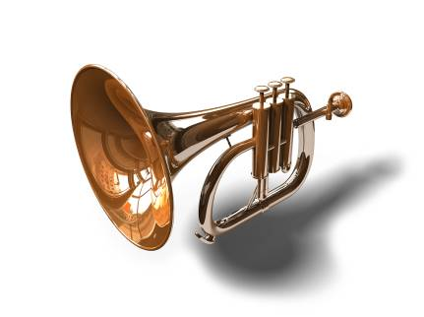



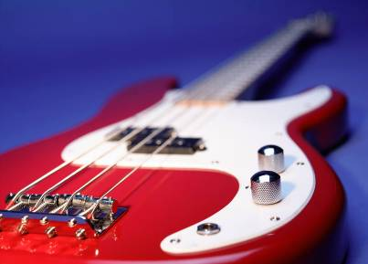
Drums Piano Trumpet

Guitar Bell Maracas

Task 4

Create a Branching Database of these materials. Sugar, Plastic, Metal, Glass, Salt, Paper, Plasticine and Cotton.

Task 5

Create a database of these sports. Football, Tennis, Swimming, Cycling, Gymnastics and Rowing.



Cycling
Football

Gymnastics Rowing


Swimming Tennis

Task 6

Create a database of these animals. Fish, owl, elephant, dog, snake and horse,

Fish

Owl

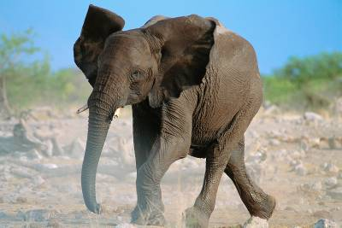
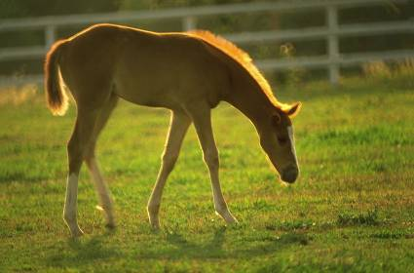
Dog Snake

Horse Elephant

