Follow the instructions below

Create a table in Word

First of all decide how many Columns and Rows you need.

Then click Table
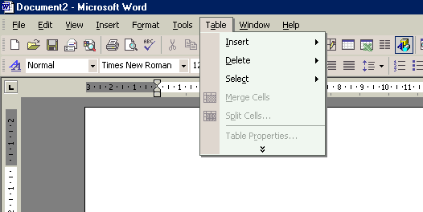

Then click insert, table.

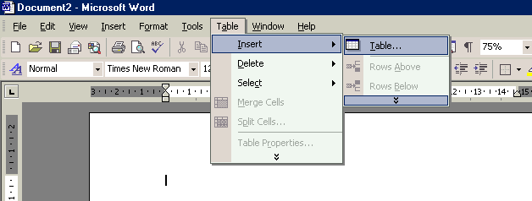

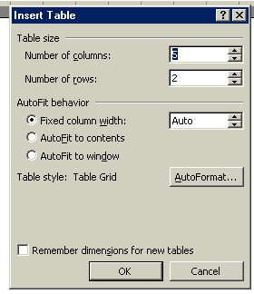
Enter how many rows and columns you need

Then click ok

Try to insert this table

Parts of the mouth | What it is for
Lips | Prevent food from falling out of the mouth while eating
Teeth | For biting and chewing food
Tongue | To help chew and swallow food
Taste buds | For tasting food
Hard palette | Hard roof of the mouth
Epiglottis | Flap of skin to close the windpipe
Windpipe | Tube that leads to the lungs for breathing
Gullet | Tube that leads from the throat to the stomach

You need 2 columns and 9 rows.

Use font size 18, style Arial.

The text will wrap itself. That means you do not have to adjust the size of the columns or rows.

Put a picture at the bottom of the human mouth.

