How to create your animation using Digital Blue

1. Create characters from Plasticine.

2. Plug the Digital Blue base into the USB port of a computer. Slot the camera into the base. It should beep.

3. Aim the camera at the area where you are going to film – you may need to prop it up on a book.
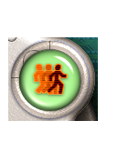
4. Open the Digital Blue Movie Creator software, (click Start then Program menu to find it).

5. Click the icon of people running (top right).
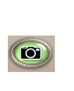
6. Get your characters into their starting positions.

7. Click the camera button on the right of the screen to capture a frame.

8. Move your character a TINY amount.
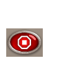
9. Repeat steps 7 and 8 until your characters have done what you wanted them to do.
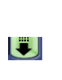
10. Press the red stop button at the bottom right.
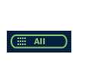
11. Click the collections button at the top.
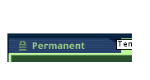
12. Under “Transfer to Permanent”, click the all button.

13. Click the Permanent tab.

14. Double click on your animation.
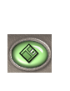
15. Press play to see your marvellous creation!

16. Don’t forget to save your masterpiece by clicking the disk at the bottom of the screen.
How to improve your animation using Digital Blue

1. Open the Digital Blue Movie Creator software, (click Start then Program menu to find it).

2. Click the scissors button on the left.


3. Find your animation in the Permanent collection and drag it onto the storyboard at the bottom.

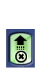
4. To add credits screens, press the arrow buttons to scroll through the collection
and choose a coloured screen. Drag it on to the storyboard after your animation.

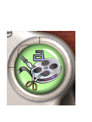
5. Press the cross at the bottom right to close the collection.

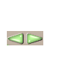
6.Click the text button to open the text editor.

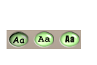
7.Choose a colour by scrolling through with the arrows and clicking on the one you want.
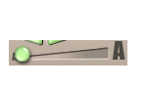
8. Choose a font by clicking one of the 3 font buttons.
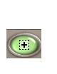
9. Make the font bigger or smaller using the slider.

10. Click the + button.
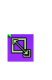
11. Type your text in the box (e.g. cast list, animators’ names, story writer’s name etc).
12. Dragging the diagonal arrow at the corner of the box will let you change the text box’s size.

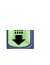
13. If your text will not fit in the box, use the slider to make it smaller.

14. To add more credits, open the collection by clicking the down arrow at the top right
and then repeat steps 4-13.

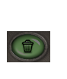
15. You can also add title screens at the start of your animation (e.g. the name of your film, who it stars etc.) by dragging a coloured screen and dropping it on top of your animation of the first box of the storyboard.

16. If you want to get rid of your text, click on it so that a green box appears around it,
then click on the dustbin at the bottom of the screen.

17. Don’t forget to save your masterpiece by clicking the disk.

You can also experiment with adding special effects and sound effects using the other menus in the editing suite. These are underneath the text button.

