Year 5 Graphical Modelling Colour Magic

Learning Objectives:

- To be able to represent the real world through graphical modelling.
- That ICT can be used to combine and manipulate shapes.
- How to move, rotate and resize graphic elements.
- Revision of copy and paste.

Activity:

- Using the Colour Magic programme, create a plan of the classroom using the tools and options in the programme.

This is the Colour Magic screen:

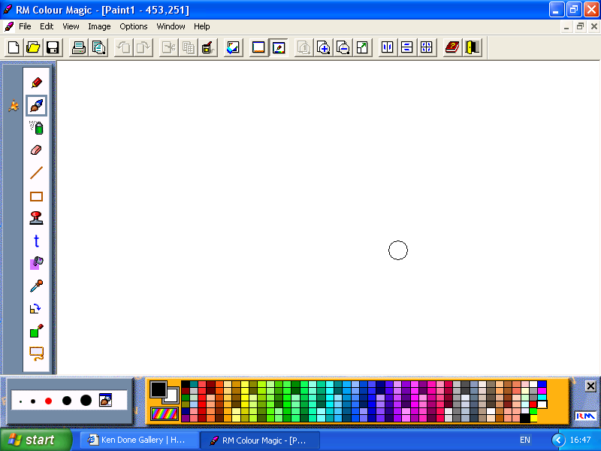
 This is the shapes tool bar

 This is the left hand tool bar with several functions – can you work out
what all the functions are?

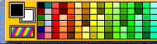 What can you do with this section at the bottom of
the screen?

Can you find these tool bars and work out what they do?



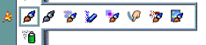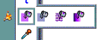

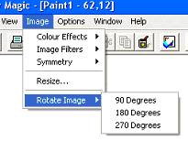 What do these options allow you to do?

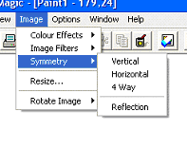
Can you work out how to label you work?
Year 5 Graphical Modelling Colour Magic

Learning Objectives:

- To be able to represent the real world through graphical modelling.
- That ICT can be used to combine and manipulate shapes.
- How to move, rotate and resize graphic elements.
- Revision of copy and paste.

Activity:

- Using the Colour Magic programme, create a plan of the classroom using the tools and options in the programme.

Starter Activity

Label the main functions indicated by the arrows below:

LA

