Computer Keyboard

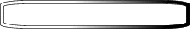
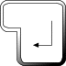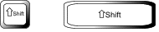
The Backspace key
The Enter or Return key
The Shift keys

The Up arrow
The Left arrow
The Down arrow
The Right arrow
The Space Bar

Put the correct keys in the sentences below

- The change a lower case letter to a capital.
- The moves the cursor to the left.

- The makes a space between words.

- The moves the cursor up.

- The makes a new line.

- The moves the cursor to the right.

- The deletes the last character you typed.

- The moves the cursor down.

