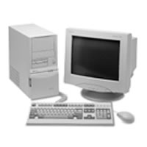 | Parts of a computer 1

Write the name and purpose of the parts of the computer below next to the correct photograph.

- Floppy drive  - Keyboard | - Monitor  - Mouse | - CD ROM / DVD ROM drive

 |  | Name: | Purpose:
1. | 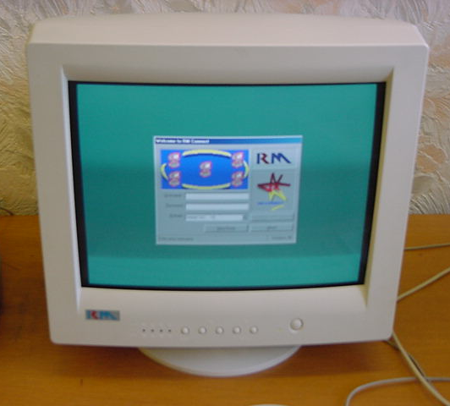 | _______________ | ____________________________________________________________
2. | 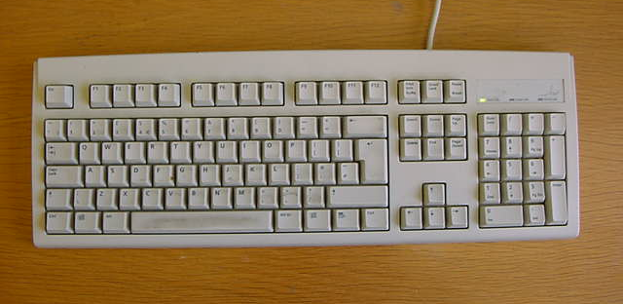 | _______________ | ____________________________________________________________
3. | 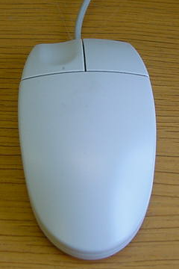 | _______________ | ____________________________________________________________
4. | 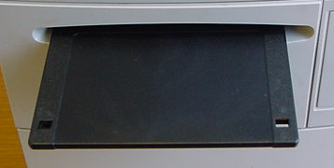 | _______________ | ____________________________________________________________
5. | 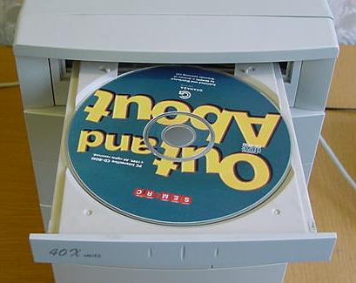 | _______________ | ____________________________________________________________

Parts of a computer 2

Write the name and purpose of the parts of the computer below next to the correct photograph.

- Scanner  - CPU | - Hard drive  - Printer | - Case

 |  | This is a: | It is used for:
1. | 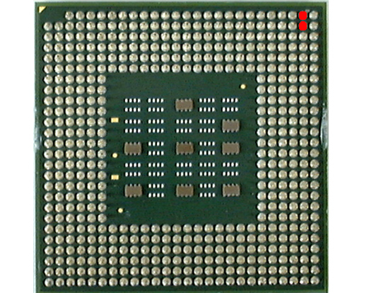 | _______________ | ____________________________________________________________
2. | 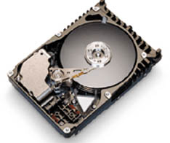 | _______________ | ____________________________________________________________
3. | 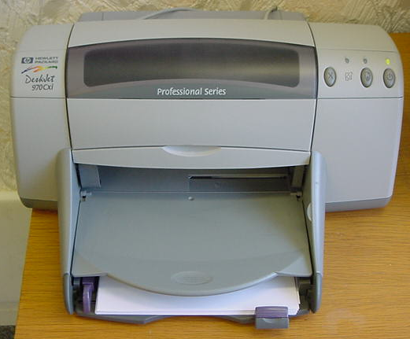 | _______________ | ____________________________________________________________
4. | 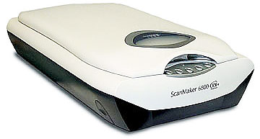 | _______________ | ____________________________________________________________
5. |     

