Year 4 ICT lesson 1 – evaluating websites
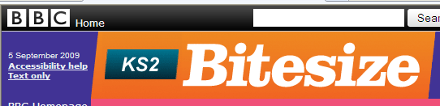

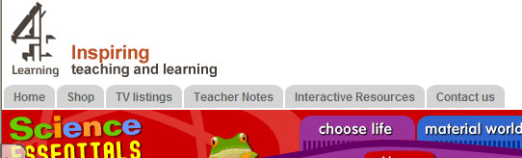

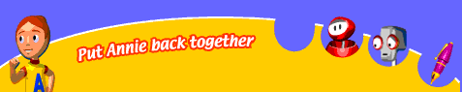

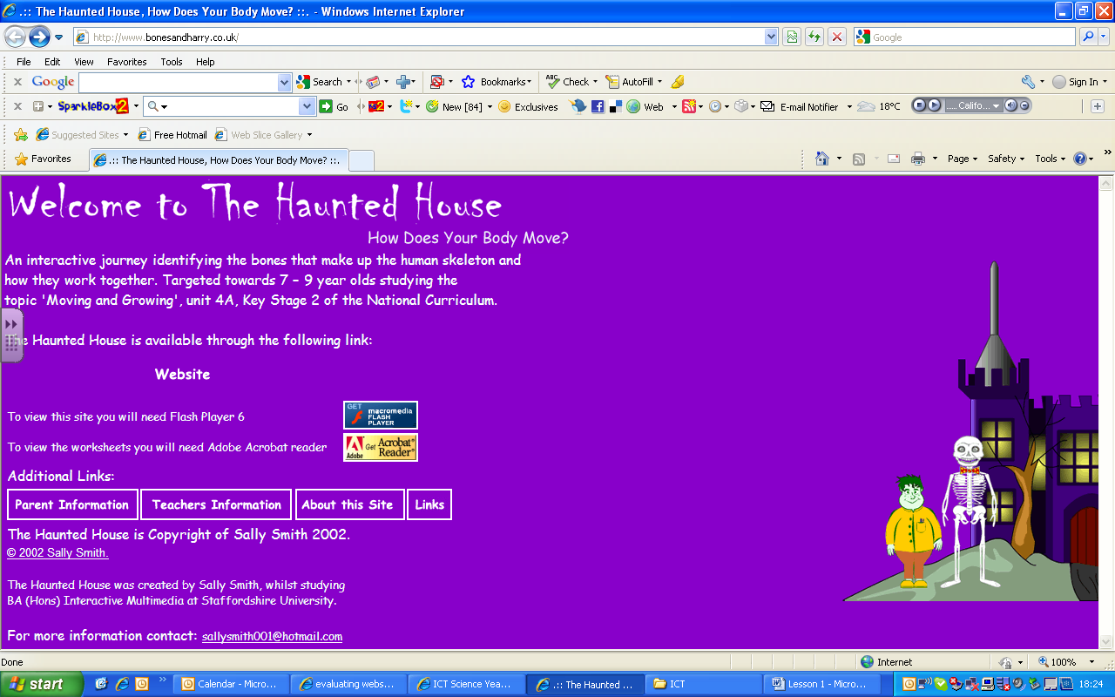

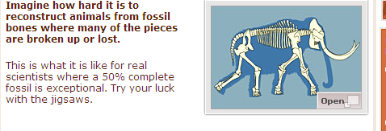 Click on the picture to get to the animation.

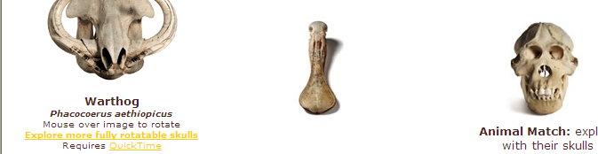

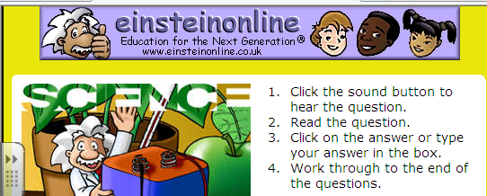

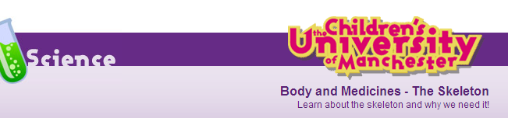
Rate each website 1 -10 | Good layout, pictures and fonts – good to look at.  1 – 10 | Easy to learn about the skeleton.  1- 10 | Easy to find your way around the website.  1 - 10 | Easy to read and understand.  1 - 10 | Total points

