Asking Questions

You can use the query function to get the database to sort information quickly for you.

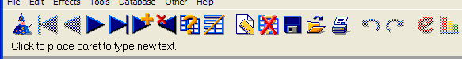

Click the Query button to ask a question

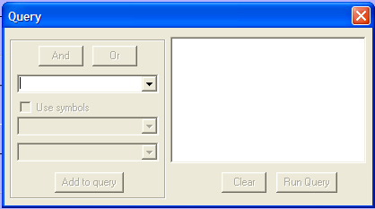
This is the Query box.

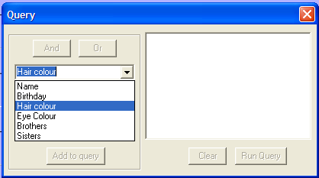
Let’s imagine we want to know how many children in the class have brown hair.

Select Hair colour from the first drop-down menu.

Then use the second drop-down menu to select “is equal to”. This means we want the database to look for exactly what we type next.

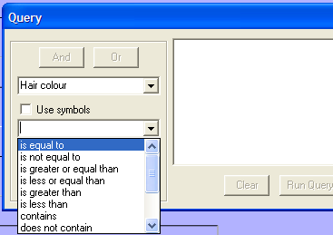
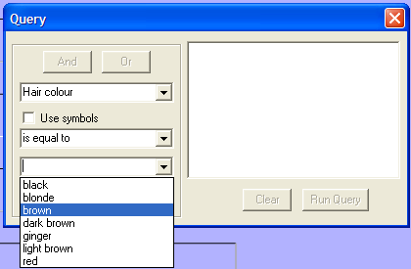
From the 3rd drop-down box, select the hair colour you want the database to look for:

Then click “Add to Query”. Your query will appear in the white box to the right, and you’re ready to go!

Now click “Run Query”.

Your results will appear as individual records and the database will tell you how many records it has found.
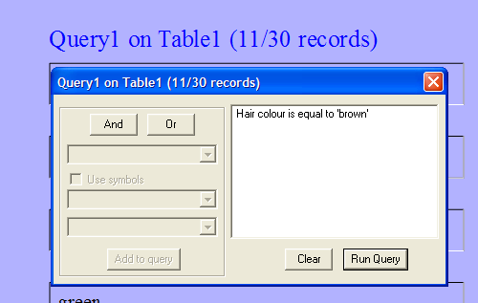
This means that 11 out of the 30 people in our database have brown hair.

If you want to see the results as a table instead. click the Change the Data View button.

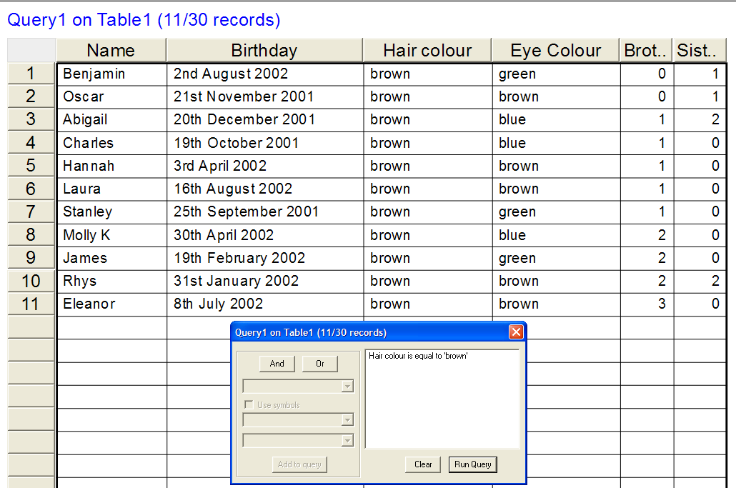
Your results will look like this:

Now you can see everyone who has brown hair all on one screen.

Sometimes we want to ask the database more complicated questions, or even more than one question at a time!

Turn over the sheet to find out how…
To start a brand new query, click “Clear”

What if you wanted to find out who was born in September. Start your query in exactly the same way:
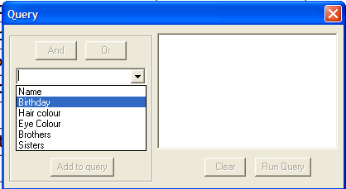
Click the Query button, then select Birthday from the first menu.

In the second box, this time we can’t select “is equal to” because nobody in our database has just the name of the month as their birthday.

Instead, we’ll choose “contains”. Then the database will look for all the records that contain the word we choose.
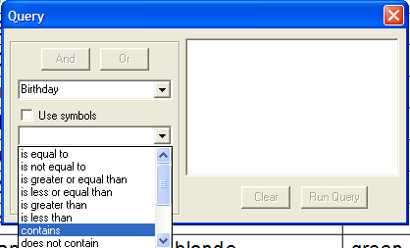
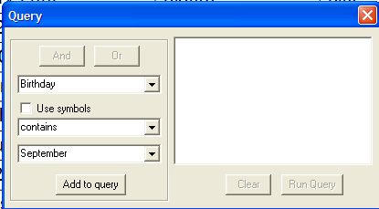
If we click on the drop-down button for the third box, it will show us all the entries that are in the birthday fields for us to choose from. But we don’t want to search for just one of these dates! So we can just type what we want into the box instead.

Then you’re ready to go – so click “Add to query” then “Run Query”.

Asking more than one question at a time

Imagine we wanted to find out who has brown hair AND has a birthday in September. We could just look at the results of one of the searches above and count the results ourselves. But when your database starts getting bigger and bigger, this gets harder and harder! So we’ll ask the database to do all the hard work for us.

This is how you do it (follow the instructions if you get lost):
- Start a new query
- Set up your query “Hair colour is equal to brown”
- Click “Add to query”
- DON’T click Run Query yet!
- Click the “AND” button.
- Set up another query in the same box, “Birthday contains September”
- Click “Add to query”
- Now click “Run Query” and your results will appear.

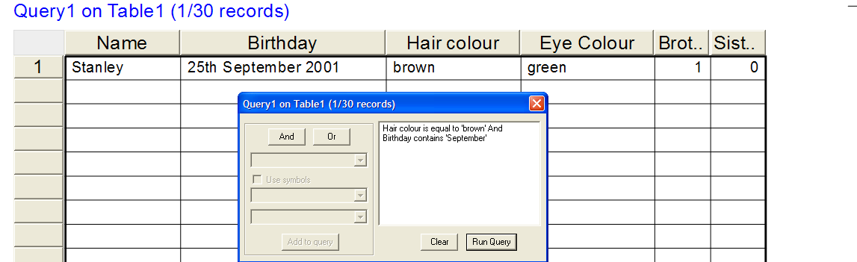

You can use the OR button in the same way. For example, you could search for people who have 1 brother OR 1 sister.

HAPPY QUERYING!
Name: _______________________________ Date: ______________________________

Asking Questions

Can you use the query function in your database to quickly answer the following questions?

1) How many children have brown hair?

2) How many children were born in 2001?

3) How many children were born in August?

4) How many children born in December have blue eyes?

5) How many children who have no brothers have brown eyes?

6) How many children have brown hair and only one brother?

7) How many children have blonde hair and blue eyes?

