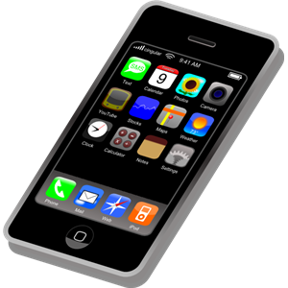 | Tech Terms  word search | 

t | s | a | j | w | w | v | n | j | s | y | k | t | e | y
x | w | c | i | i | v | b | m | m | x | o | n | a | r | t
z | u | i | x | d | l | o | a | j | o | j | o | b | k | p
u | t | o | t | u | e | r | h | b | z | u | c | l | m | p
h | s | r | r | t | t | p | e | g | g | h | i | e | r | a
b | p | a | j | p | e | c | i | r | q | c | t | t | d | n
g | y | x | h | f | a | r | i | k | k | o | o | b | e | q
u | e | o | d | f | c | b | m | m | i | j | m | s | p | d
g | n | p | h | i | s | h | i | n | g | w | e | q | f | i
e | x | z | j | h | y | o | s | f | c | s | y | y | y | o
k | r | u | b | a | w | l | q | y | g | s | p | w | i | j
q | h | v | z | o | g | v | o | k | k | s | w | m | d | t
s | u | r | i | v | i | t | n | a | l | e | a | l | o | n
n | t | m | g | y | a | i | b | r | k | p | f | p | p | j
f | v | o | s | u | q | v | c | g | q | v | i | z | h | n

Can you find all the Tech Terms below in the word search?

- antivirus | - app | - bluray
- ebook | - emoticon | - facebook
- jpeg | - phishing | - smartphone
- tablet | - twitter | - wikipedia

 | Tech Terms  - Internet | 

1. | What is cloud computing?

2. | Draw an emoticon:

3. | Who founded Facebook?

4. | Write down the Twitter address of a famous person:

5. | Write down the name of an anti-spyware program:

6. | What is phishing?

7. | Write down a URL:

8. | Write down the name of an article on Wikipedia:

9. | Write down the name of something you could buy on eBay:

10 | Write down the names of four websites you use in College:

 | Tech Terms  - Hardware | 

1. | What is a smartphone?

2. | Name three makes of smartphone:

3. | Name three smartphone operating systems:

4. | Name three useful smartphone apps:

5. | What is a tablet computer?

6. | What is Blu-ray?

7. | What is plug and play?

 | Tech Terms  - Software | 

1. | Write down the name of an antivirus program:

2. | Why do you need  up-to-date antivirus software?

3. | What is an App Store?

4. | What does Bcc mean?

5. | What is an e-book reader?

6. | Write down the title of an e-book:

7. | What is a JPEG?

8. | Write down the website address of a blog: | - www.

9. | Write down the name of an MP3 track:

10 | Write down the names of five software programs used in College:

