How to edit a film using Microsoft Movie Maker

By Entry Level students

We had finished filming all the scenes of our film. We wanted to make them into one long film. We wanted to add titles (words) and music.

Equipment you need

1. A computer. We used a portable laptop computer. | 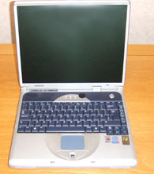
2. Film editing software. We used a program called Microsoft Movie Maker 2. It is a part of Microsoft Windows XP. | 

How to use the software

1. Click on the Start button. | 
2. Click on the All Programs icon.
3. Click on the Windows Movie Maker icon.
4. Click on Import Video and find your first scene of animation. Click on Import.
5. Drag and drop the scene onto the Video timeline. | 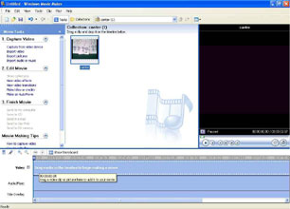
6. Click on Import Video again and drag and drop all your scenes onto the timeline.

7. Click on Make titles or credits.
8. Choose which type of title you would like to use. | 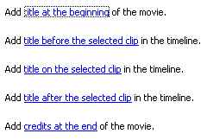
9. Click on Make titles or credits again and add titles (words) to all your scenes.
10. Click on Import audio or music and find your music.
11. Click on Import.
12. Drag and drop the music onto the Audio/Music timeline. | 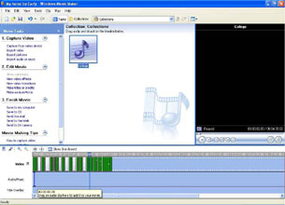
13. Click on the Play button to play your film. | 
14. Click on the Save Project button if you would like to make changes in the future.
15. Give your project a name, such as ‘A ride on my horse’. Click on Save.
16. Click on Finish Movie. Choose which type of format you would like to save your film. Follow the instructions to save your film.

Instructions also available on the SymbolWorld website. To view go to www.symbolworld.org click on Learning, click on Life Skills, click on ICT. Alternatively go to http://www.symbolworld.org/learning/life_skills/it/movie_maker/movie1.htm

