ICT: Unit 6A  Multimedia Presentation |  | Mountfield Primary School

Making a PowerPoint Presentation: The Title Page
Choose the slide layout which suits you. Put in a title. In this example, “Fun with Maths” To make the title bigger you must take the curser to the beginning or end of the sentence and with your finger on the left button of the mouse drag the curser across the sentence to highlight it.
Release the left button of your mouse and take your arrow to the font size. Double click and a drop down menu will appear. See the diagram to the right. In this example the title “Fun with Maths” has been enlarged to 72 points.
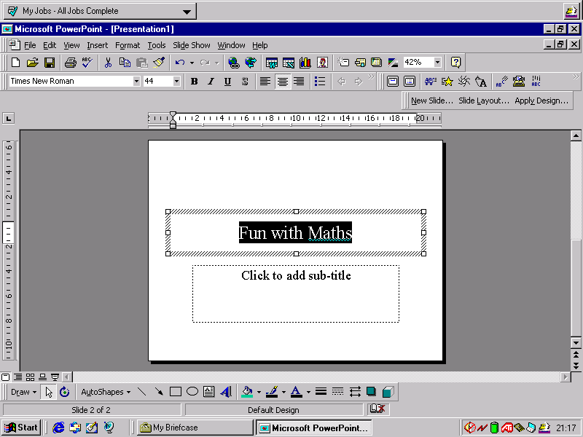
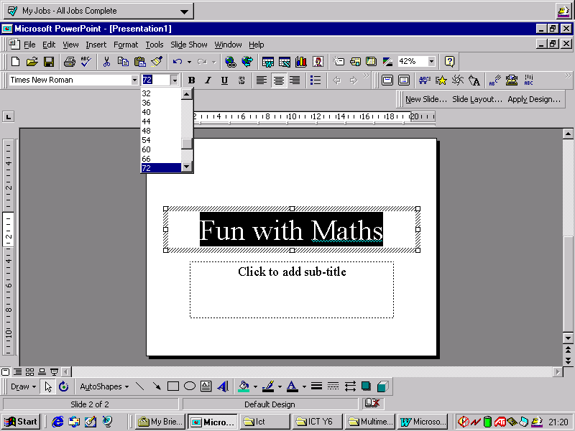

ICT: Unit 6A  Multimedia Presentation |  | Mountfield Primary School

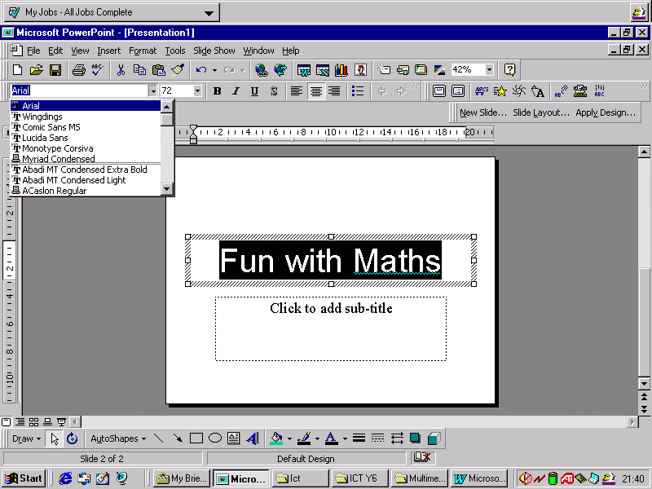

You may want to change the Font. Highlight the title as before and take your arrow to the Font name box. Double click and a drop down menu with the names of a number of Fonts will appear. Click on the Font you want. In this example Arial has been chosen.

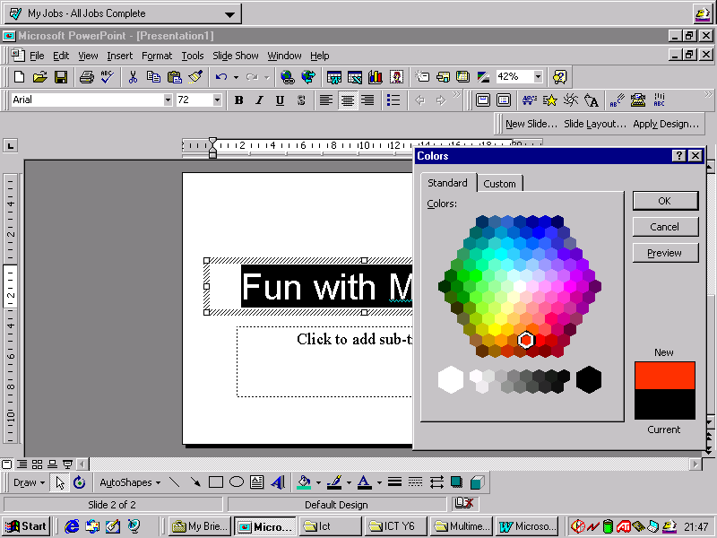

To change the colour of the title highlight as before. Take your arrow to the Font Colour button and double click. For a big choice of colours double click on More Font Colours. You will then see a hexagon full of colours. Take your arrow to the colour of your choice and double click and then click OK. In this example red has been chosen.

ICT: Unit 6A  Multimedia Presentation |  | Mountfield Primary School

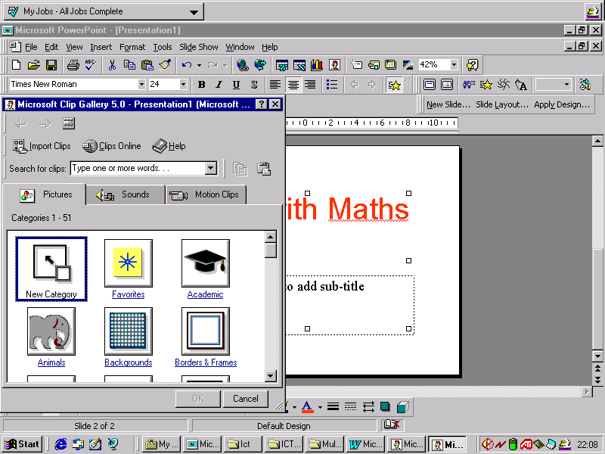

Scan through the clip art and make your selection. In this example the picture outlined in blue has been selected by double clicking . A sub menu appears. To place the picture into your title page click on the first button and close the screen.

To place a picture in the screen, double click on the sub title frame and then take your arrow to the Insert Clip Art Button. Double click and you are presented with a number of categories to choose from. In this example “Academic” has been clicked.

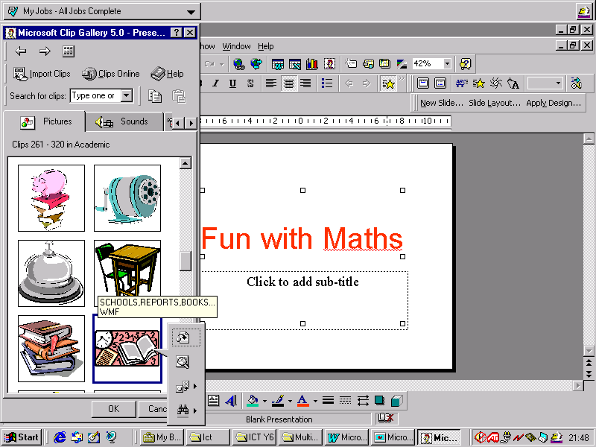

ICT: Unit 6A  Multimedia Presentation |  | Mountfield Primary School

This could be your title page or you may wish to alter the background from white to something more interesting. Take your arrow to a blank part of the presentation and right click the mouse.
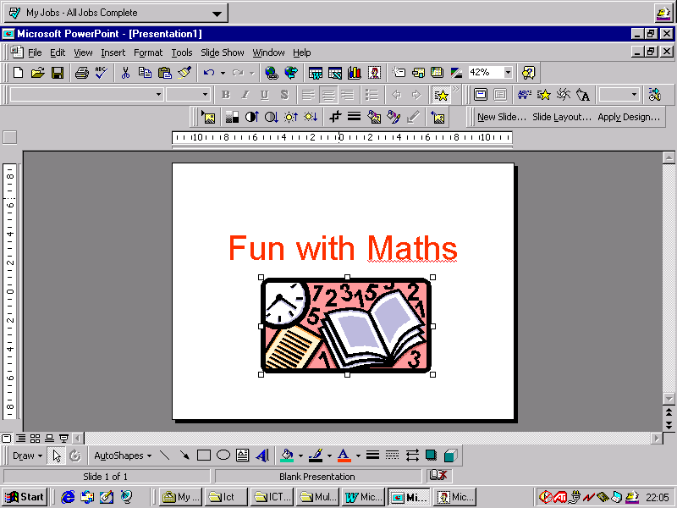

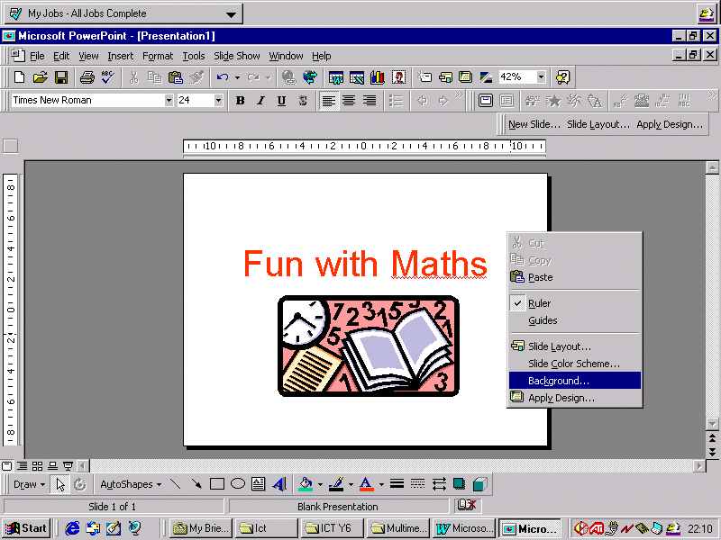

A menu appears. Double click on “Background”

ICT: Unit 6A  Multimedia Presentation |  | Mountfield Primary School

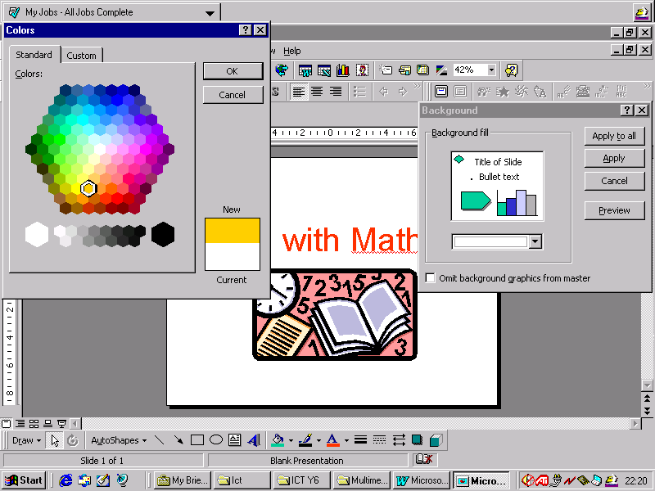
Click on the drop down arrow to reveal a colour choice. Select the colour you want and click OK.

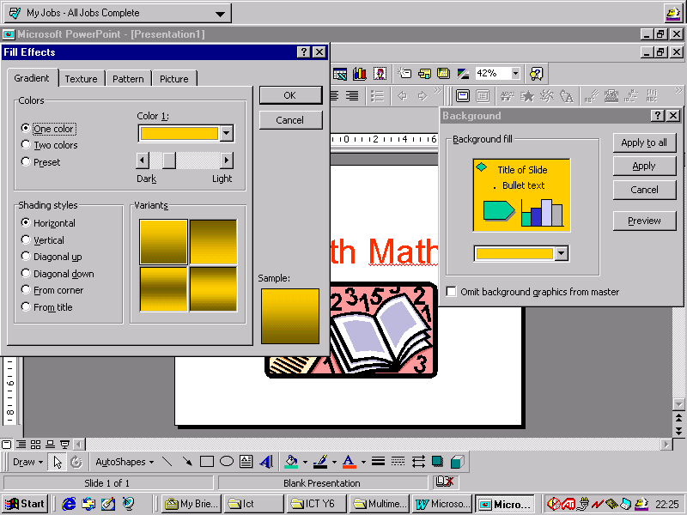
Go back to the “Background “ menu and click on the drop down arrow. Click on “Fill Effects.” In this example one colour gradient is selected. Click OK and click apply on the Background menu.

ICT: Unit 6A  Multimedia Presentation |  | Mountfield Primary School

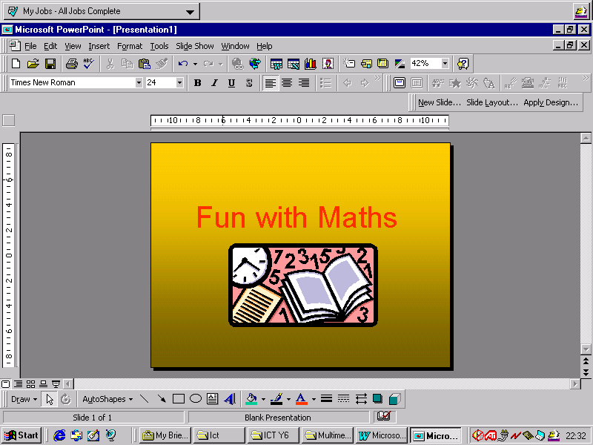
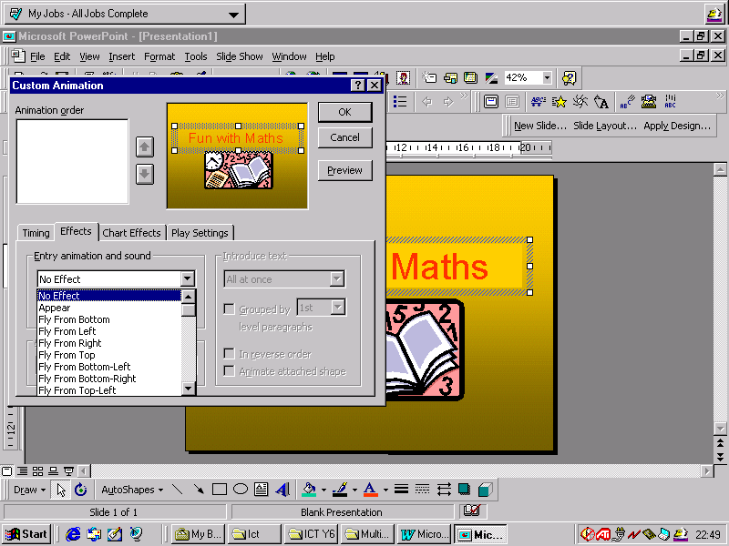
Your front page is now finished….. unless you want to introduce some animations to make it even more interesting.
Right click over the word or the picture. A menu appears. Click on “Custom Animations” Now select the effect you want and Preview. When you are satisfied with your choice click OK. You can see what it looks like by clicking on “Slide Show.”

