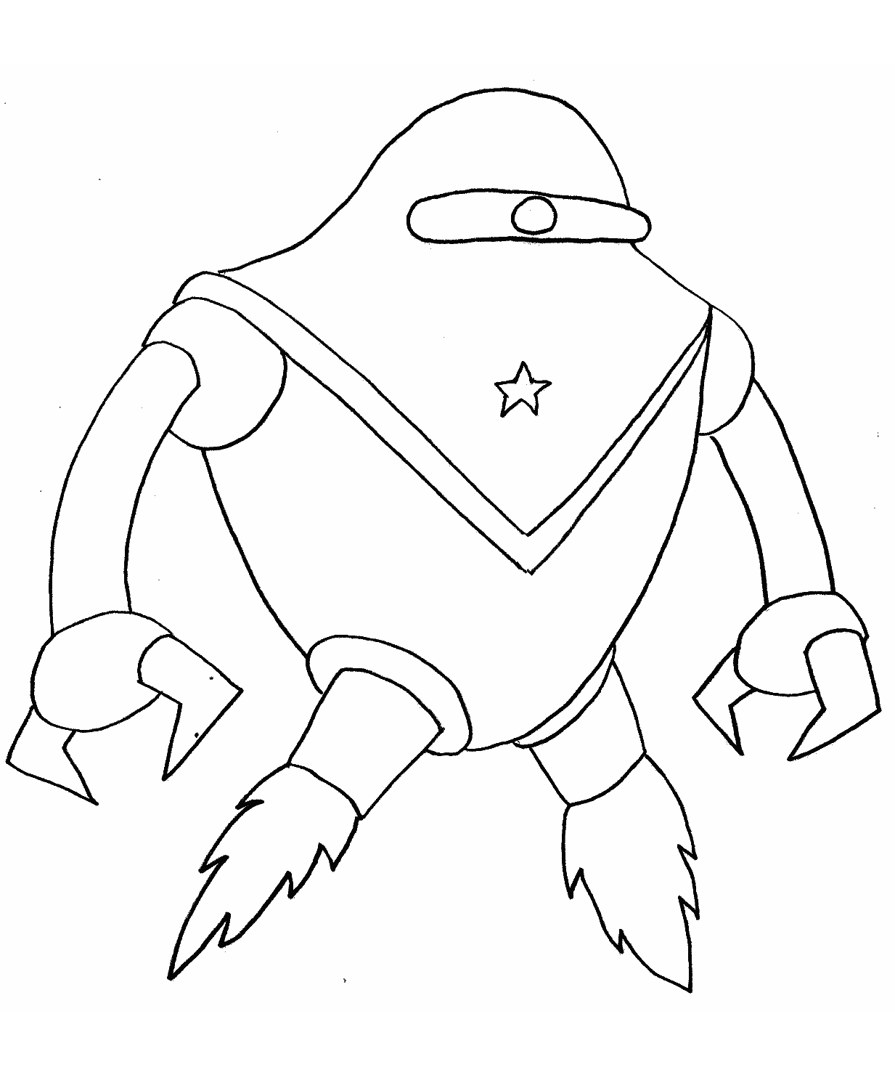
7 + 3 =
11 + 5 =
9 + 6 =
16 + 4 =
5 + 9 =

8 + 6 =

8 + 4 =

7 + 5 =

11 + 4 =
7 + 7 =

2 + 12 =

6 + 4 =

5 + 5 =
12 + 8 =
15 + 5 =

8 + 2 =
9 + 1 =

7 + 9 =
9 + 3 =
10 + 2 =
8 + 8 =

Complete the addition sums. Use the answers to find the correct colour to finish the picture.

Red – 10 | Green – 14 | Orange – 16
Blue – 12 | Yellow – 15 | Purple – 20

