Football Pictogram

Which football team does 5V support?

Look at the tally chart below and see if you can find out which football team 5V support the most?

1) Collect the data.
Tally chart

Team name | Frequency
Manchester Utd

Arsenal

Liverpool
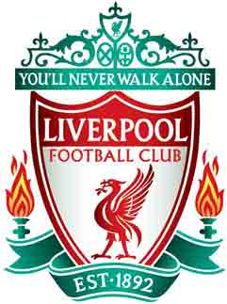

Chelsea

Tottenham Hotspur


2) Using the images, make a pictograph from the data collected above.

Answer the following questions

Which team was the most supported?
Which team was the least supported?
How many people supported Liverpool?
How many people are in the class altogether?
How many people supported Arsenal?
How many people supported both Manchester and Arsenal?
If 2 more people voted for Chelsea, how many people would support Chelsea in total?

