Divisor Spiders

Find the divisor of each spider. Record the divisors at the end of each leg.

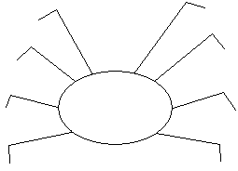
30

24

32
36

